World DB Assignment Questions (SQL Assignment):

# Basic Questions

## Questions

1. What is the world database used for?

Ans: The world database is used to access information about ‘city’, ‘country’ and ‘country language’ from all over the world that was stored and made available in the database.

1. How many tables are there in the world database?

Ans: 3 tables: city, country and countrylanguage.

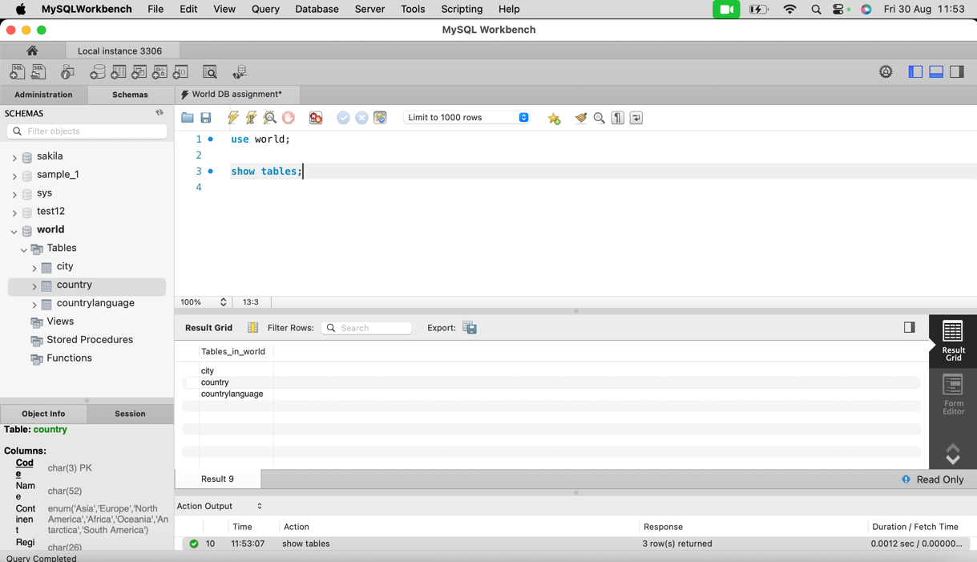

1. What does the city table store?

Ans: 5 columns: ID, Name, CountryCode, District and Population.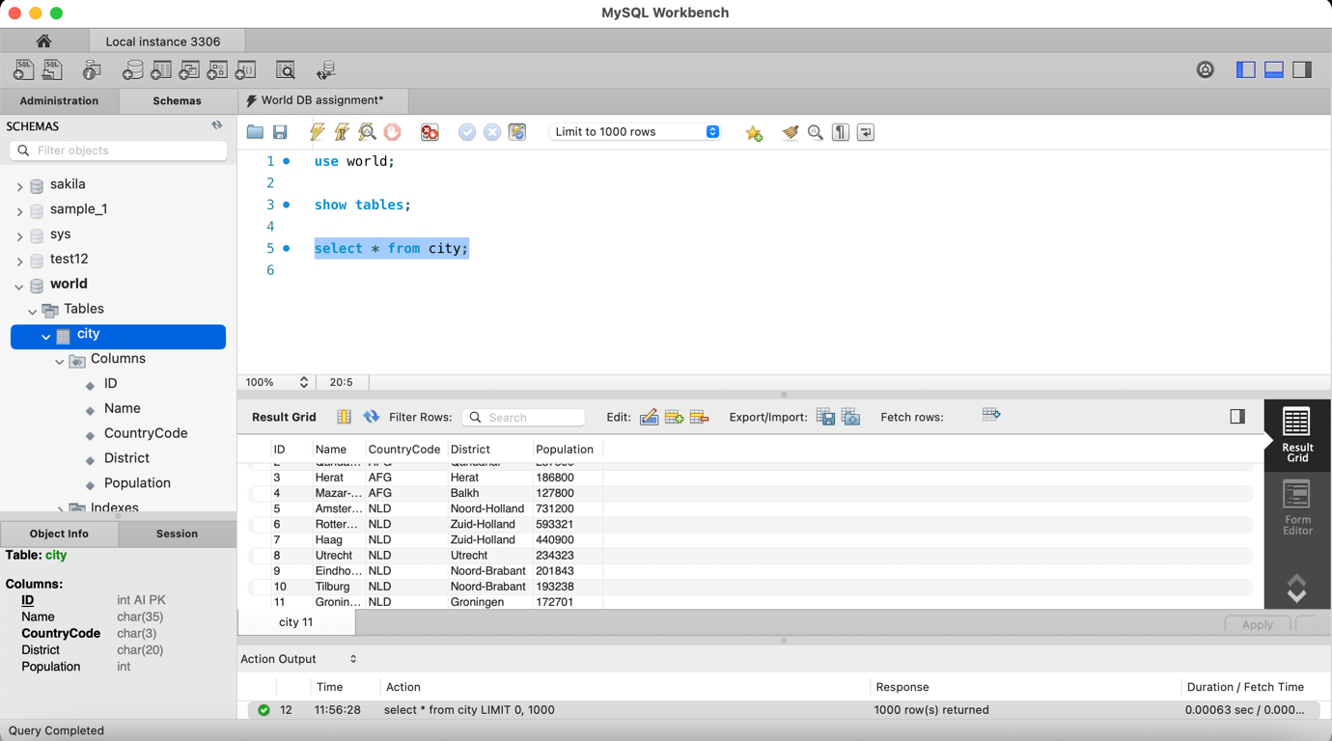

1. What does the country table store?

Ans: 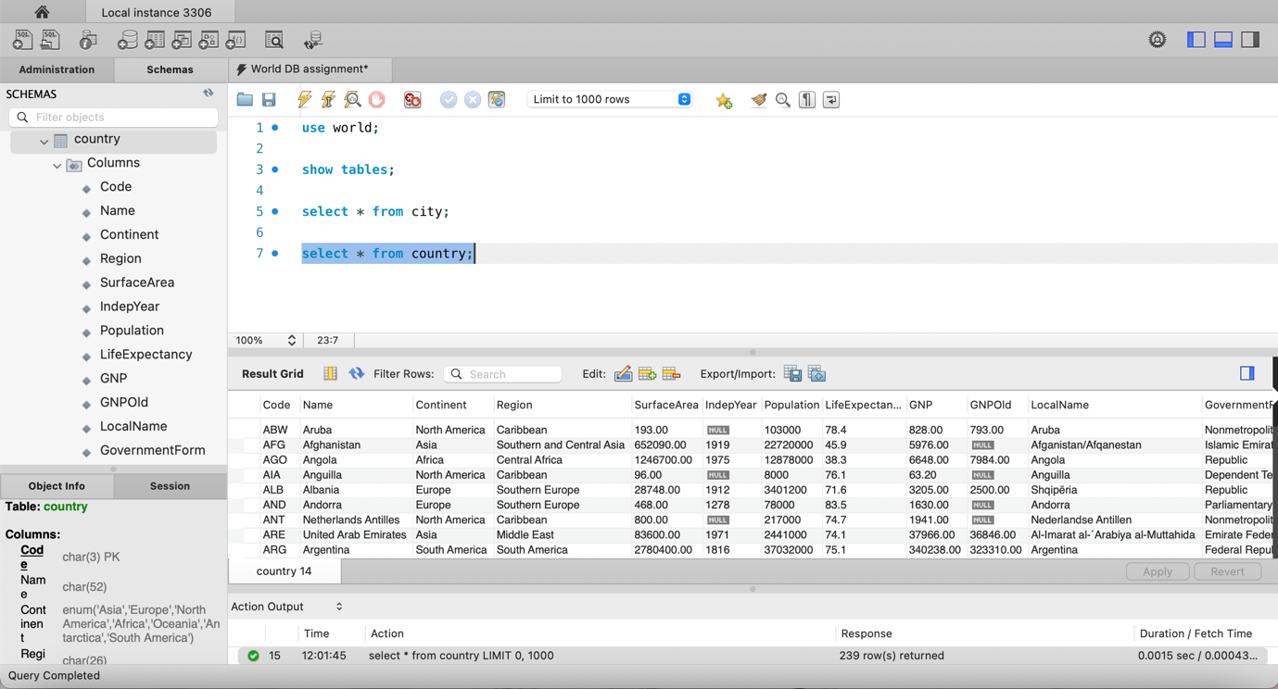

1. What does the countrylanguage table store?

Ans: 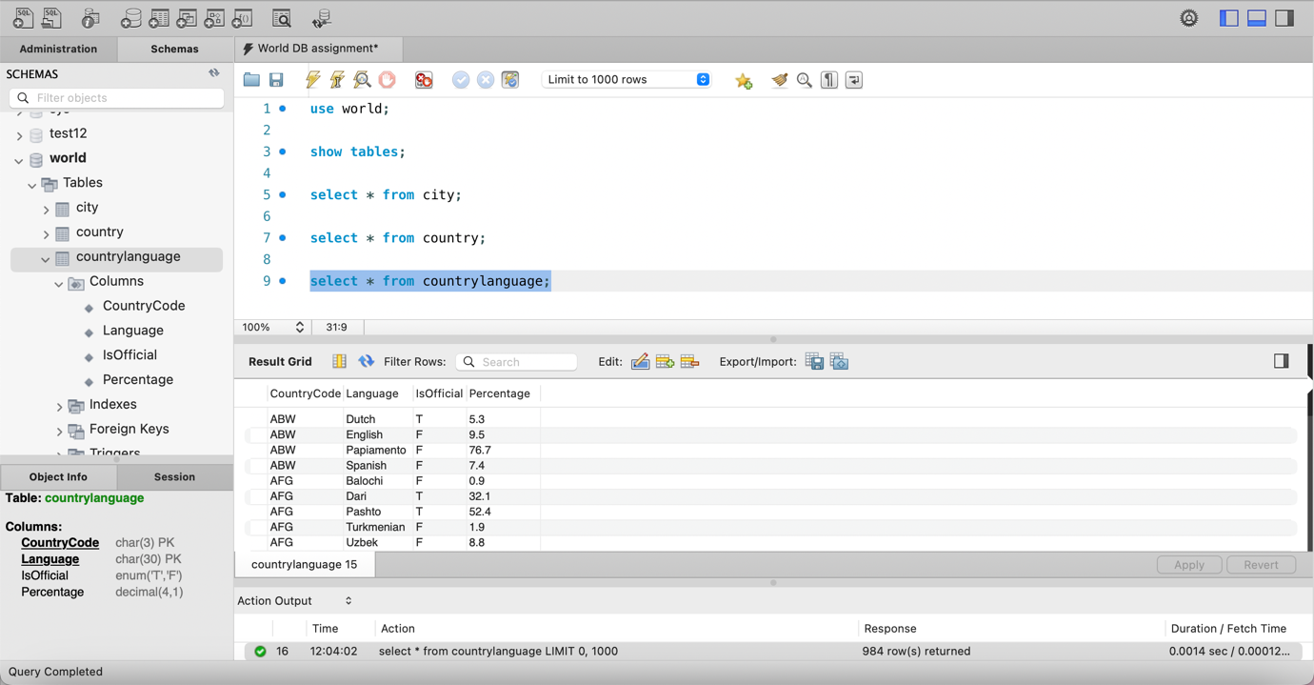

1. How can you view all tables in the world database?

Ans: Yes. Three tables –



1. How do you select the world database?

Ans: Either by typing: use world; or by double clicking the world schema on the left hand side. 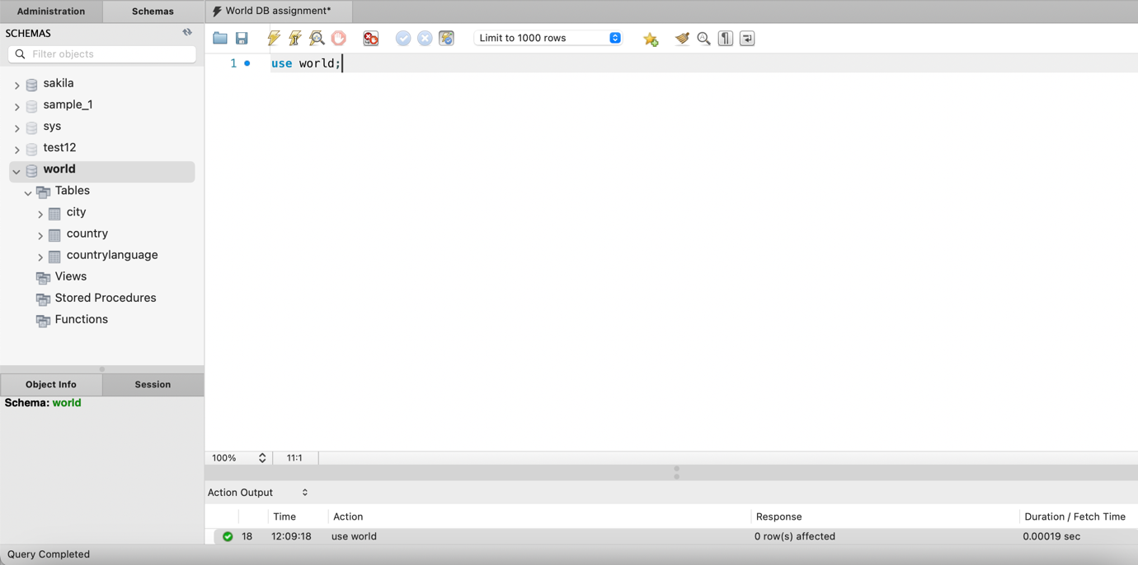

1. How do you describe the structure of the city table?

Ans: 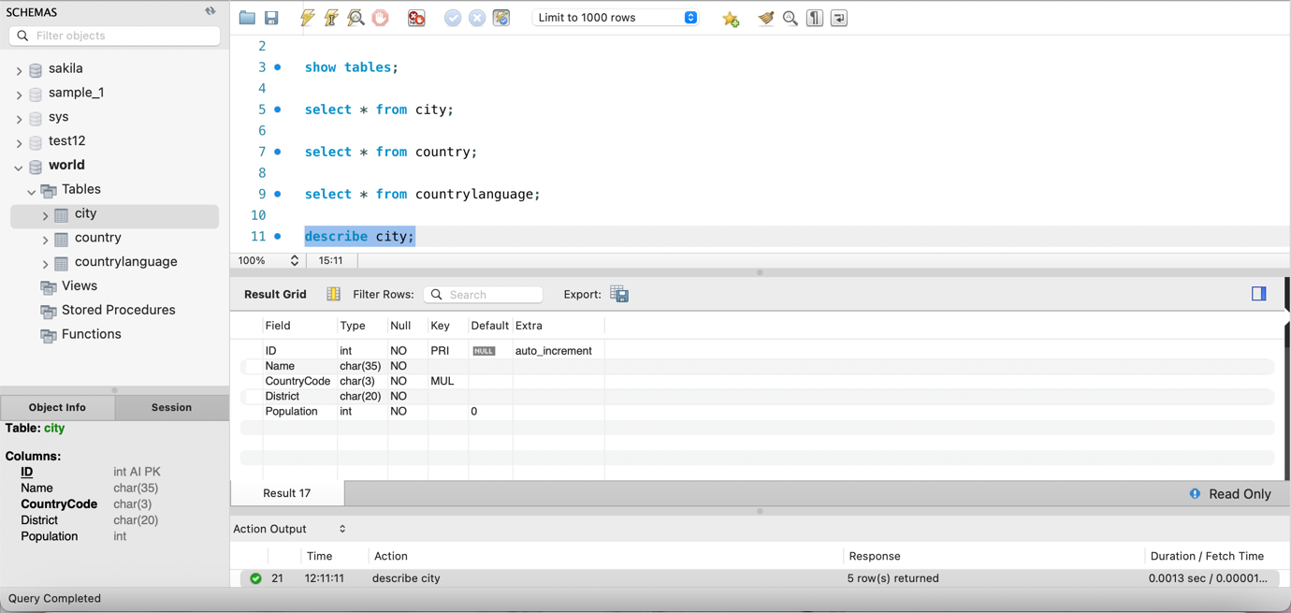

1. How do you list all cities in the city table?

Ans: 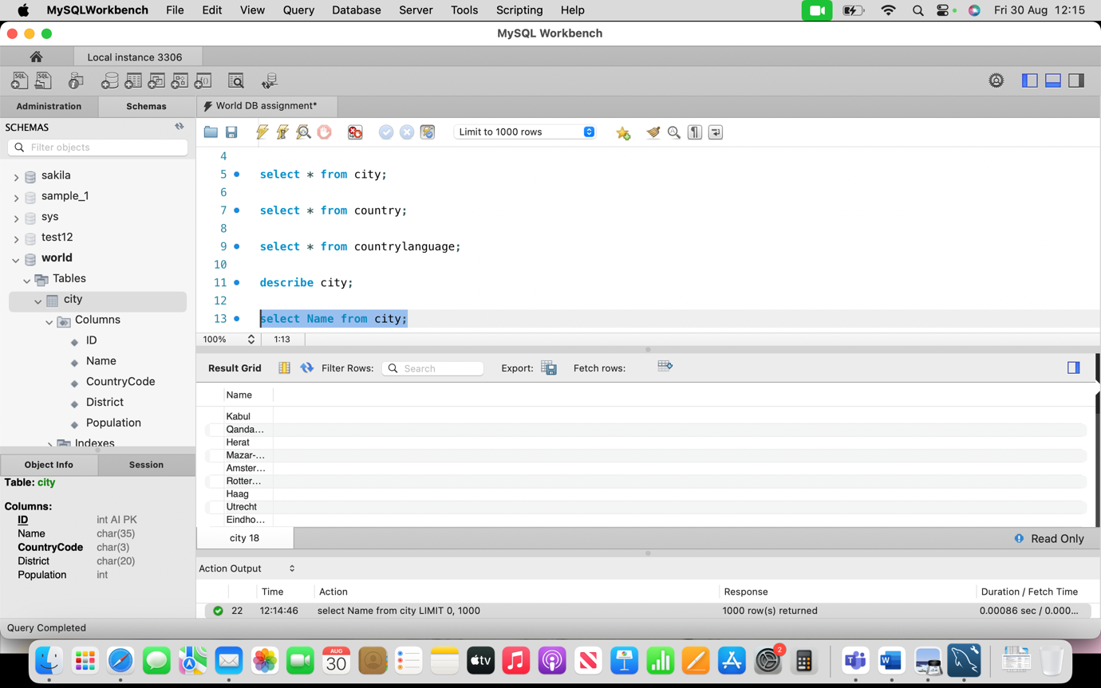

1. How do you find the number of rows in the country table?

Ans: 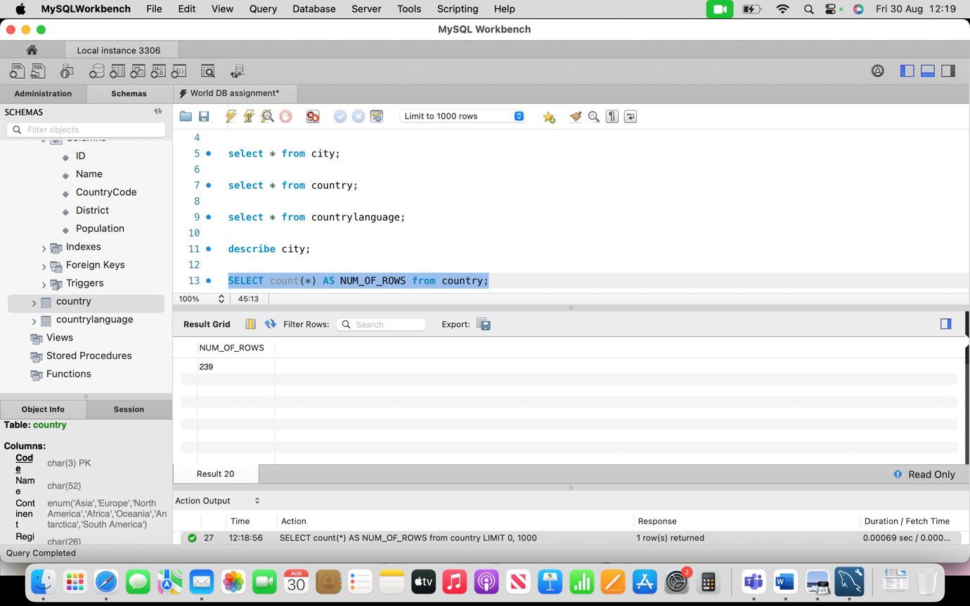

1. How do you find the population of a specific city?

Ans: 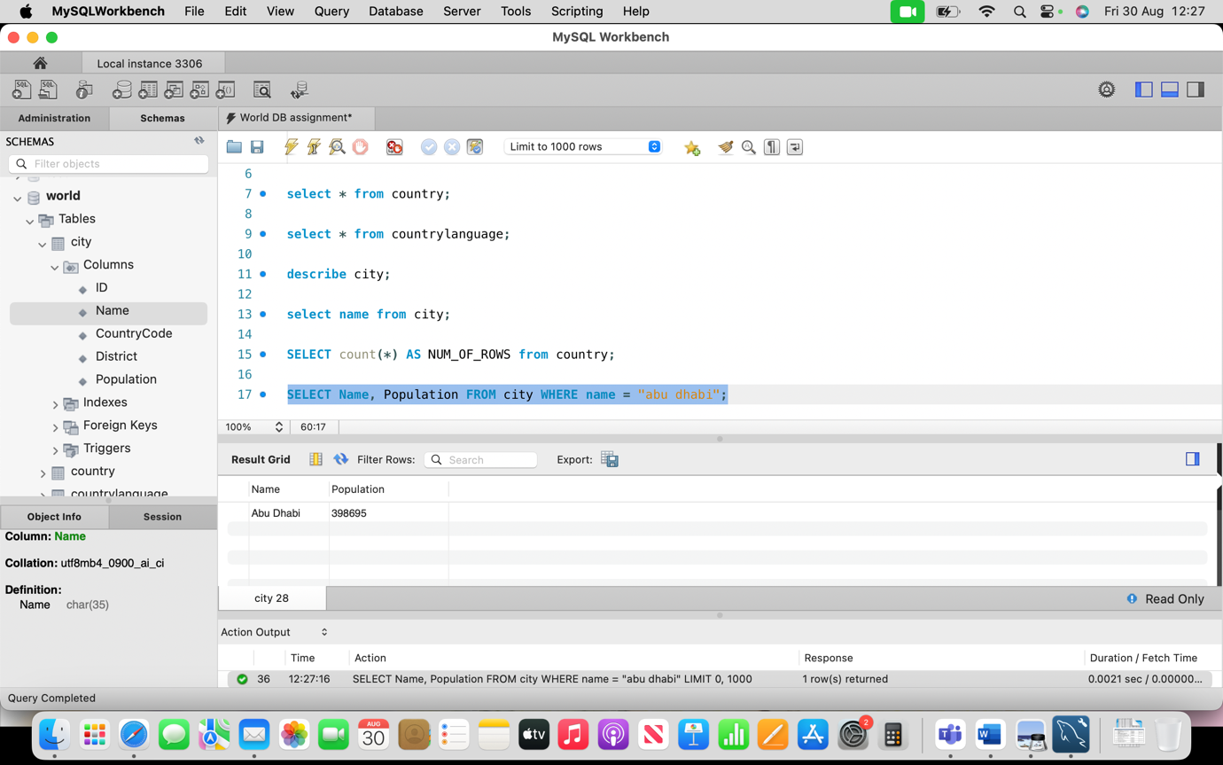

1. How do you insert a new city into the city table?

Ans: 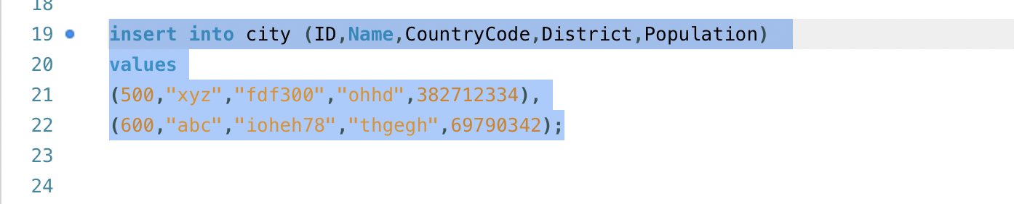

1. How do you delete a city from the city table?

Ans: 

1. How do you update the population of a city?

Ans: 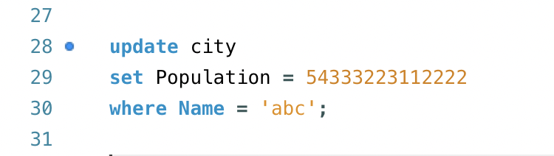

1. How do you find all countries in a specific continent?

Ans: 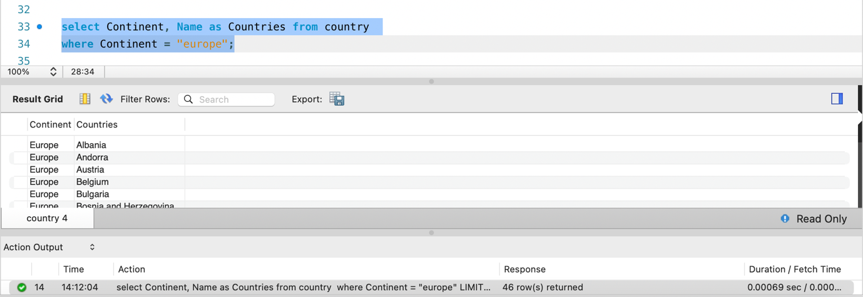

1. How do you find the capital city of a country?

Ans: 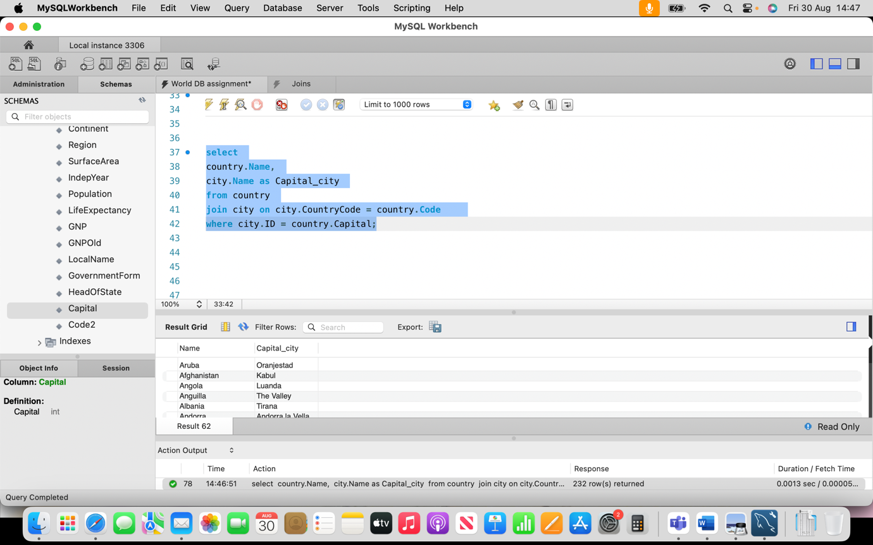

1. How do you find all languages spoken in a specific country?

Ans: 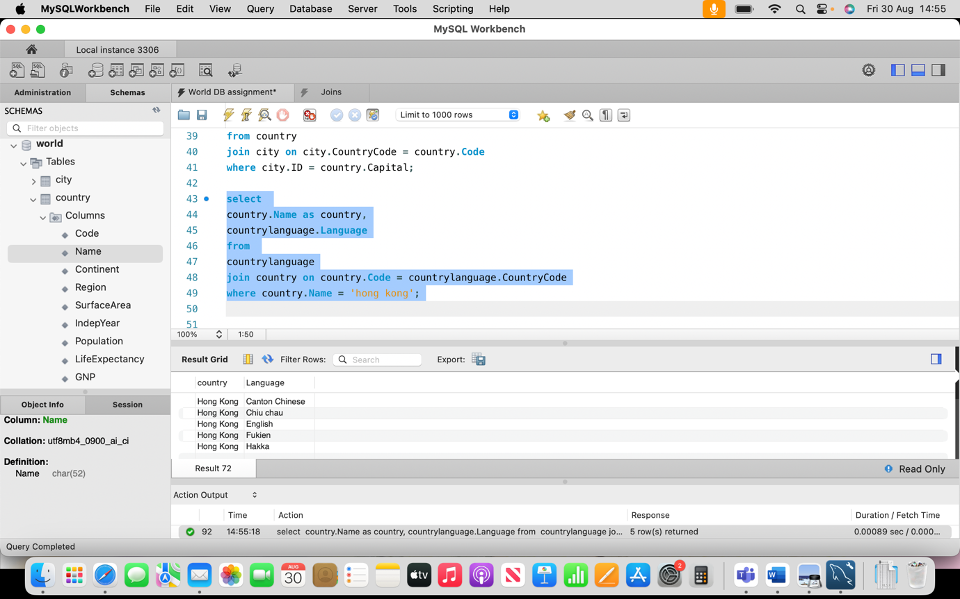

1. How do you find the official languages of a country?

Ans: 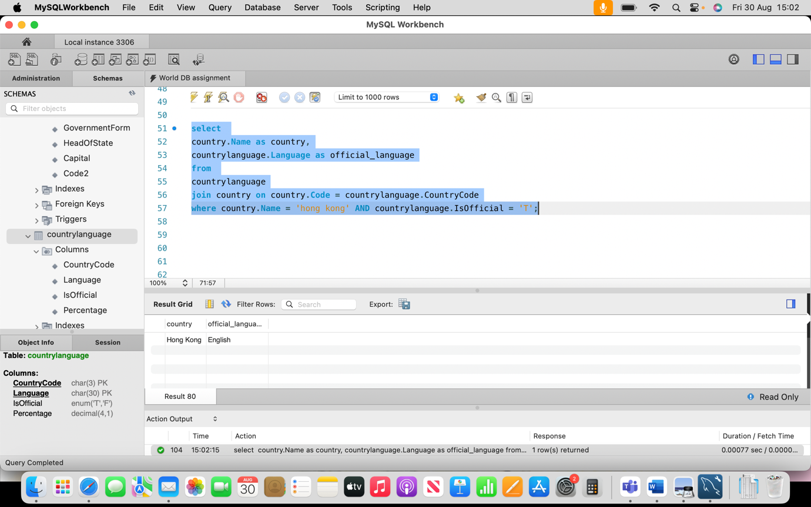

1. How do you find the countries with a population greater than 100 million?

Ans: 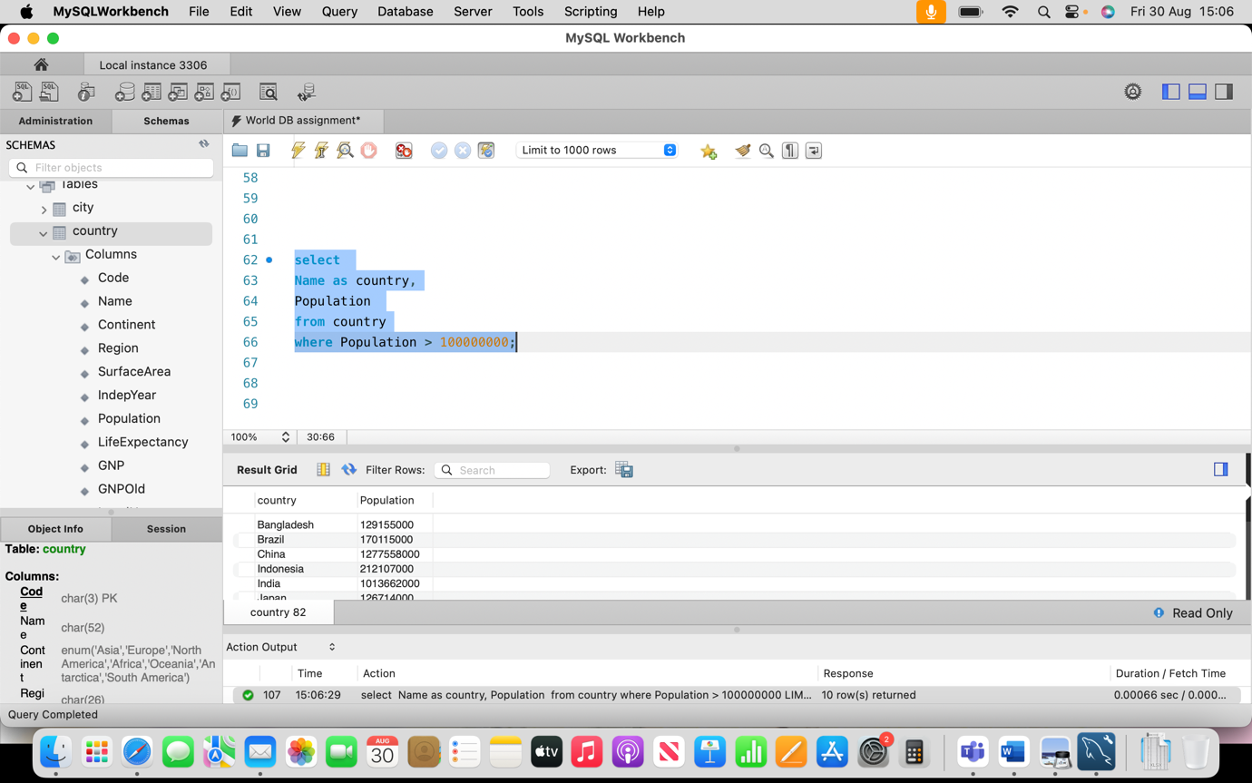

1. How do you find the countries in the 'Asia' continent?

Ans: 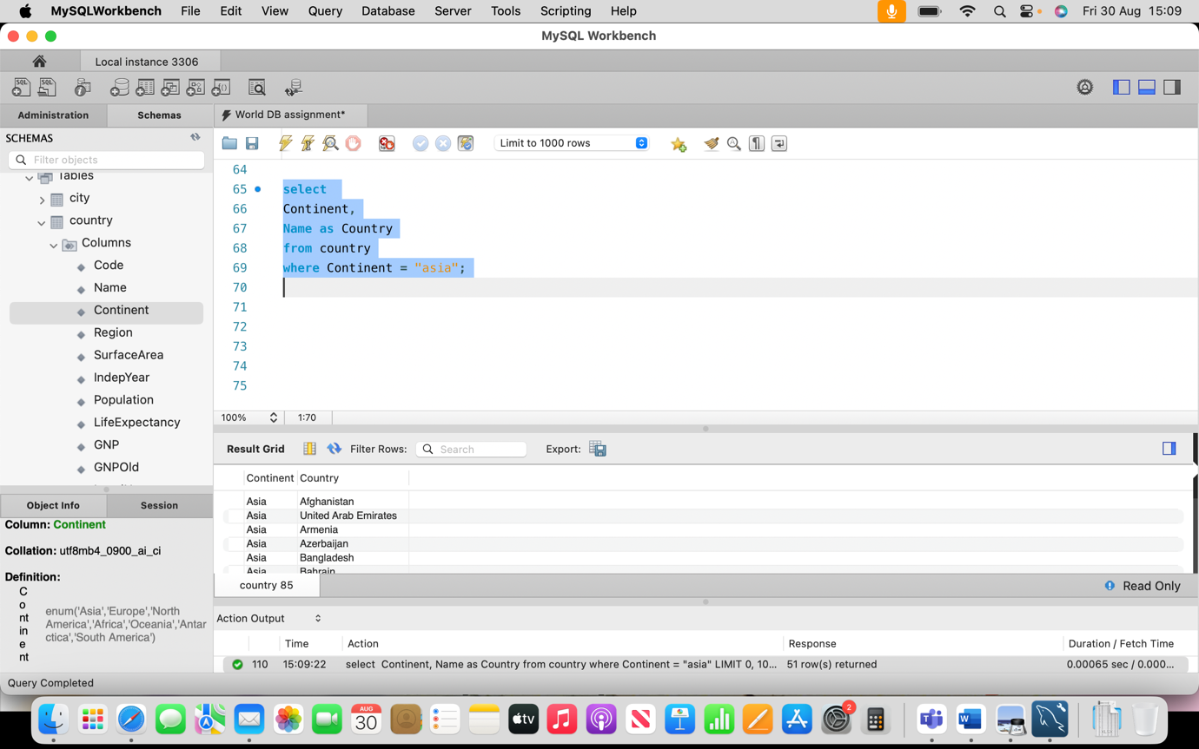

# Intermediate Questions

## Questions

1. How do you find the average population of all cities?

Ans: 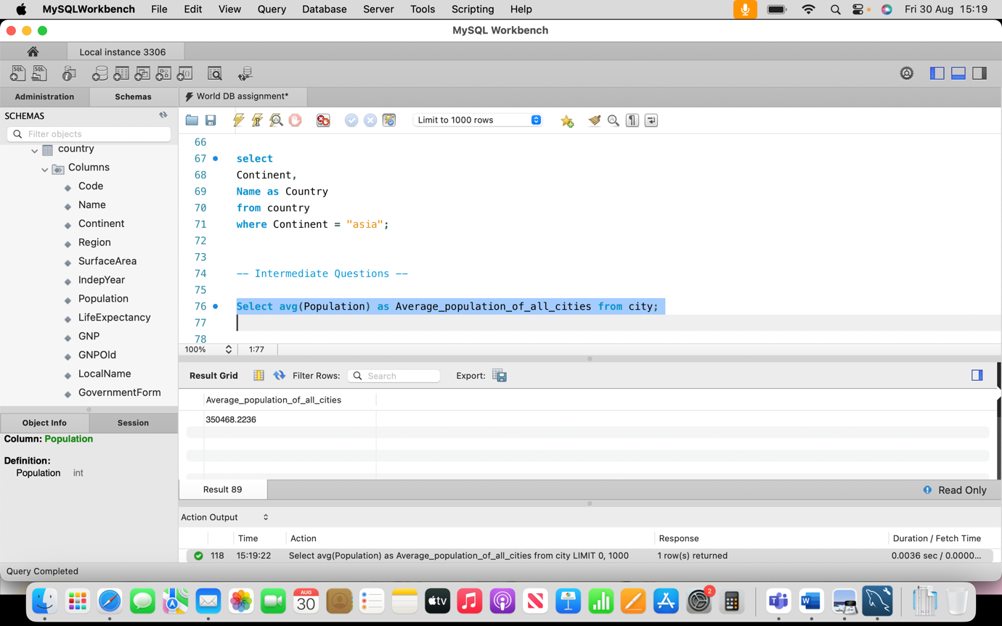

1. How do you find the total population of a specific country?

Ans: 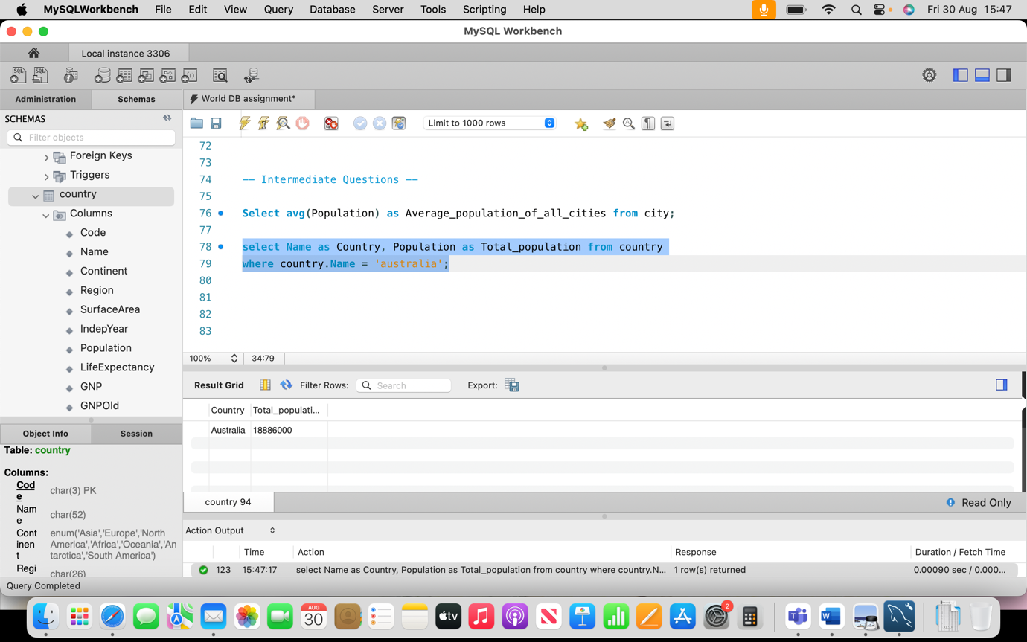

1. How do you find the number of cities in each country?

Ans: 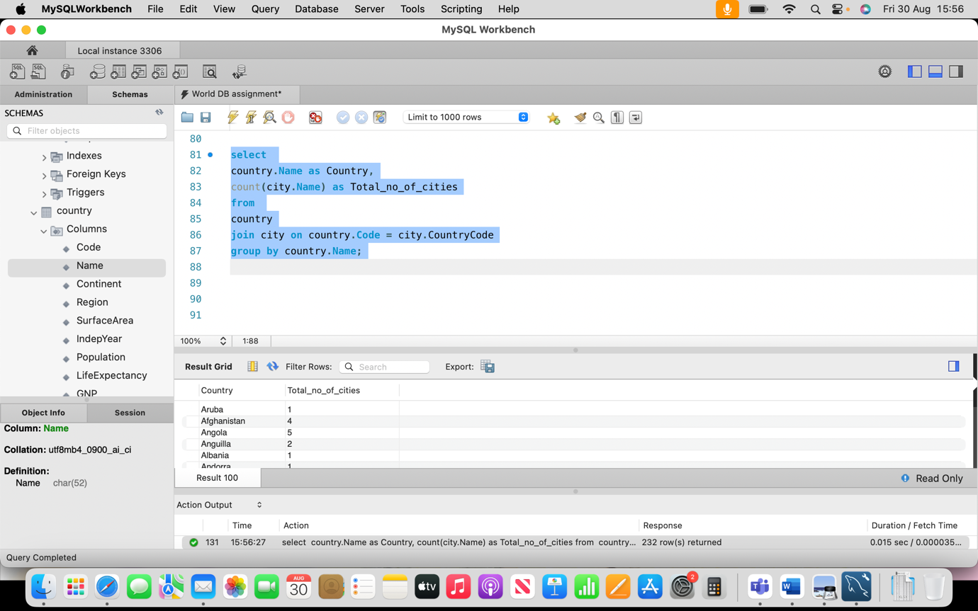

1. How do you find the top 5 most populated countries?

Ans: 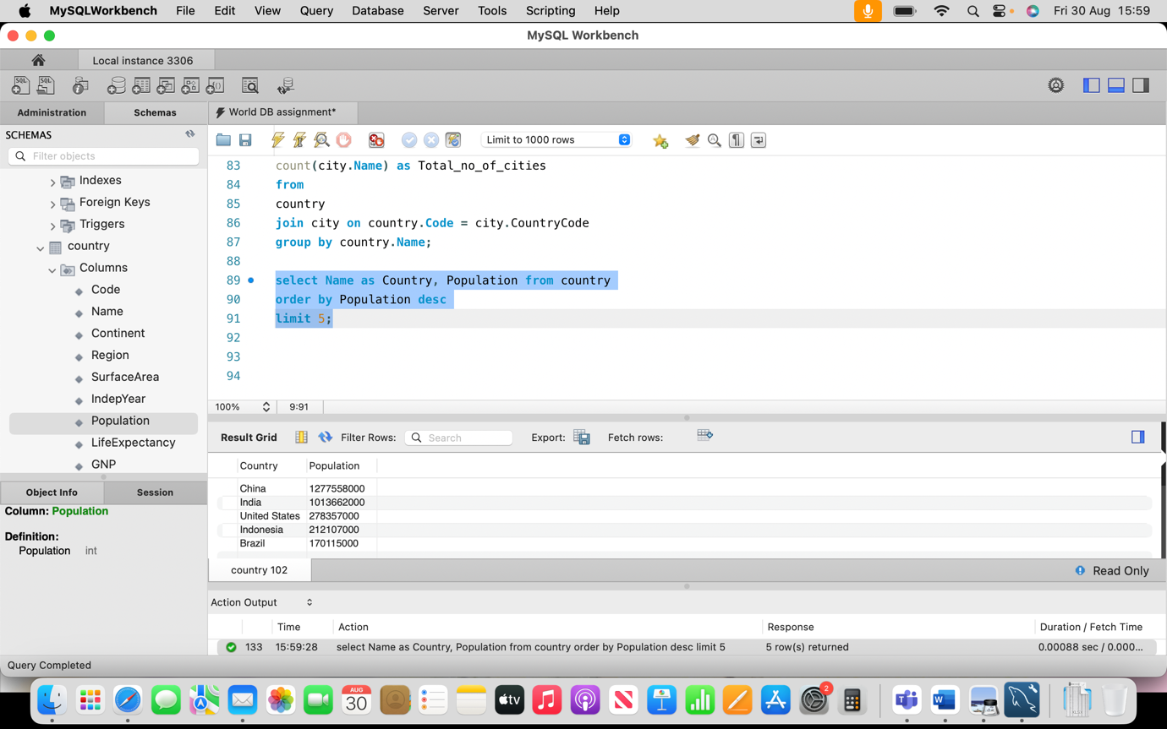

1. How do you find the least populated city?

Ans: 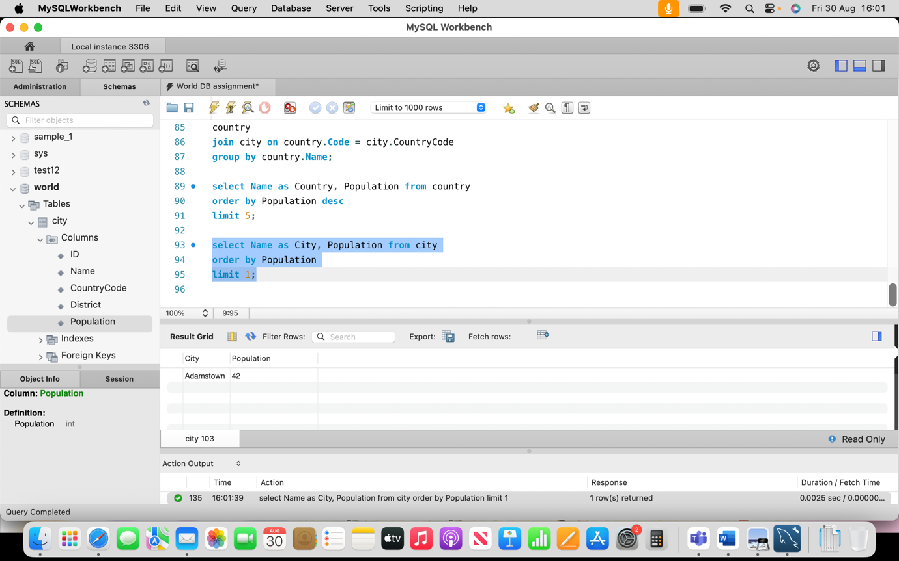

1. How do you find the countries with a life expectancy greater than 80 years?

Ans: 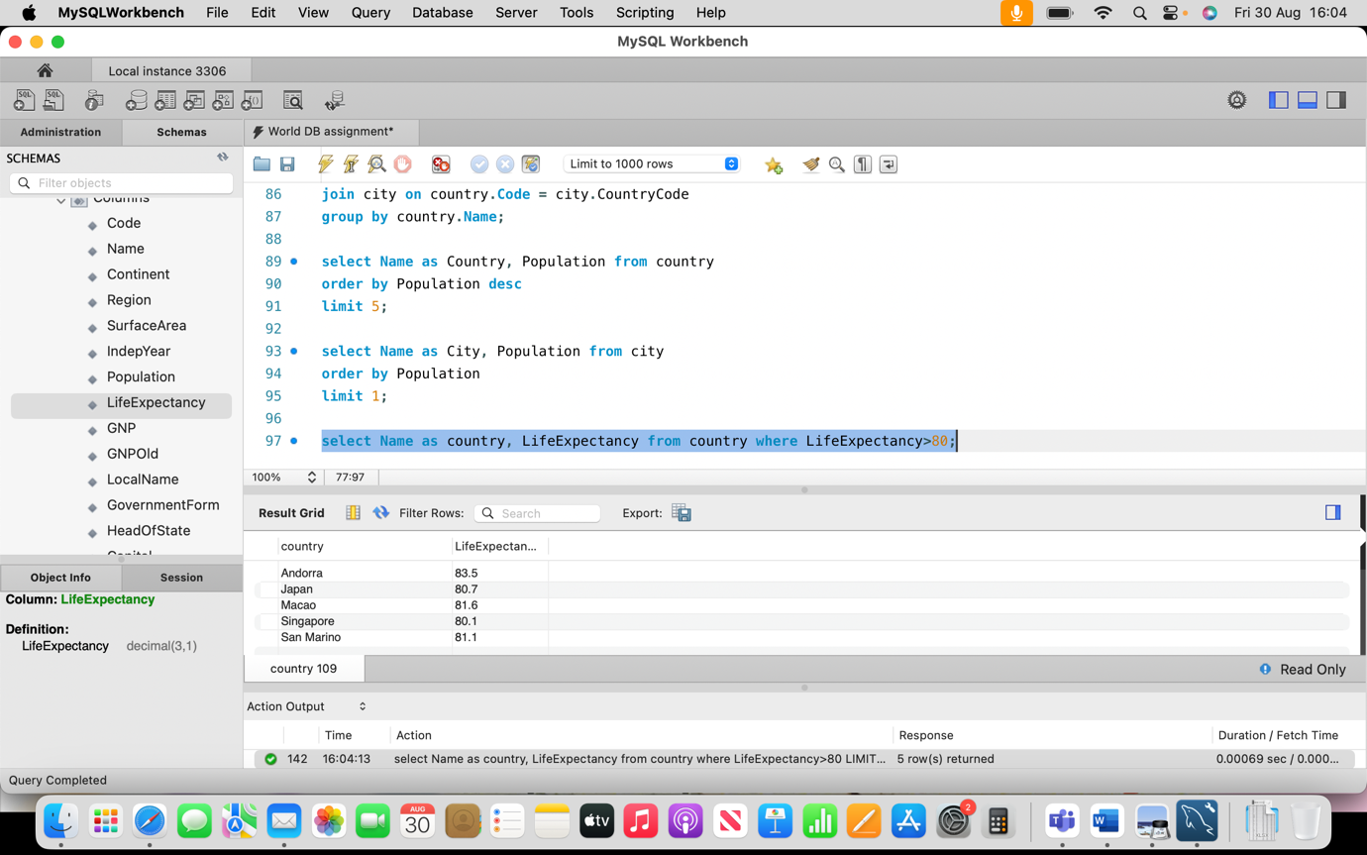

1. How do you find the countries with a GNP greater than 1 trillion?

Ans: 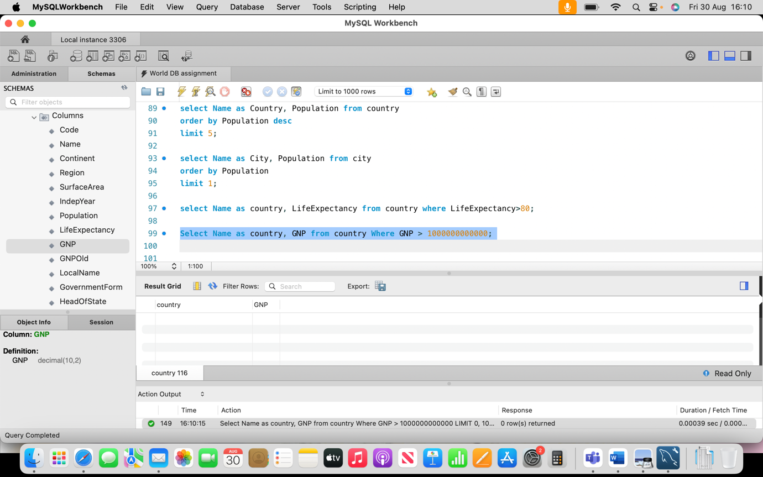

1. How do you find the countries that gained independence after 1950?

Ans: 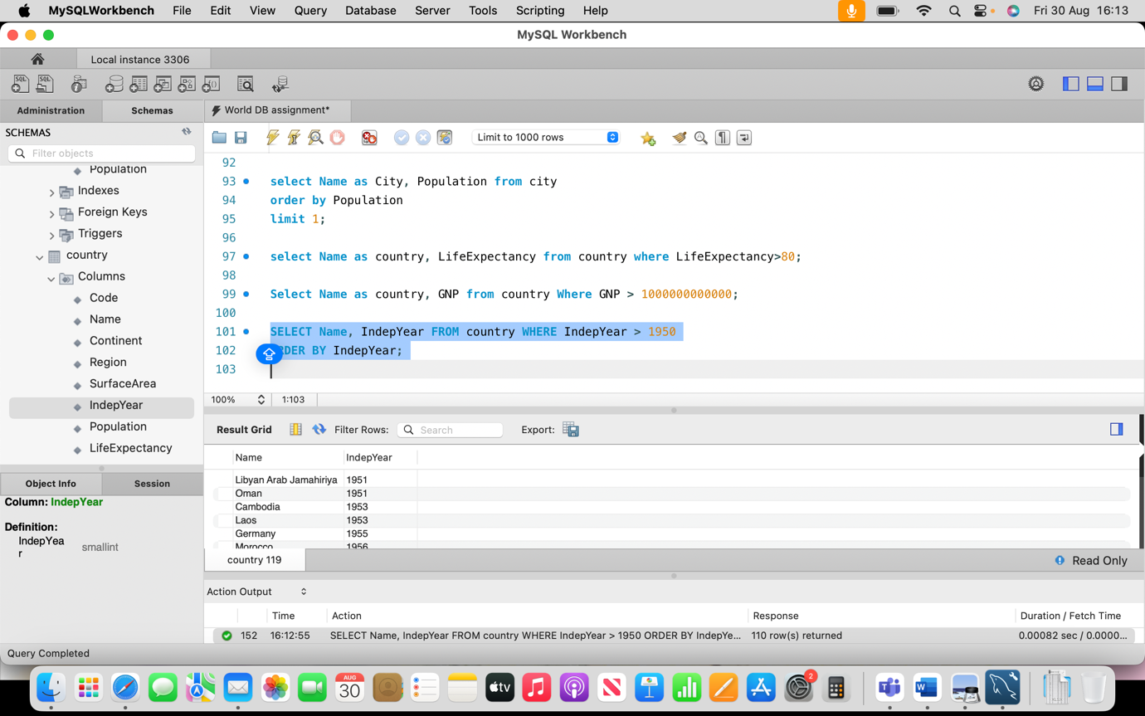

1. How do you find the countries with more than one official language?

Ans: 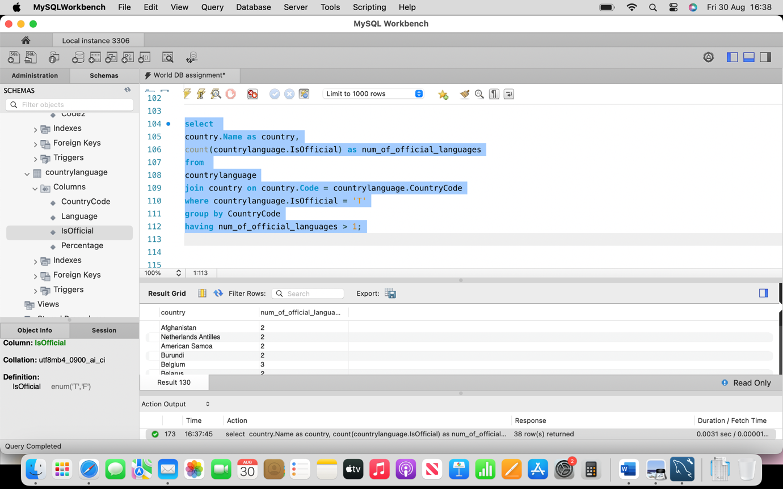

1. How do you find the cities in the 'California' district?

Ans: 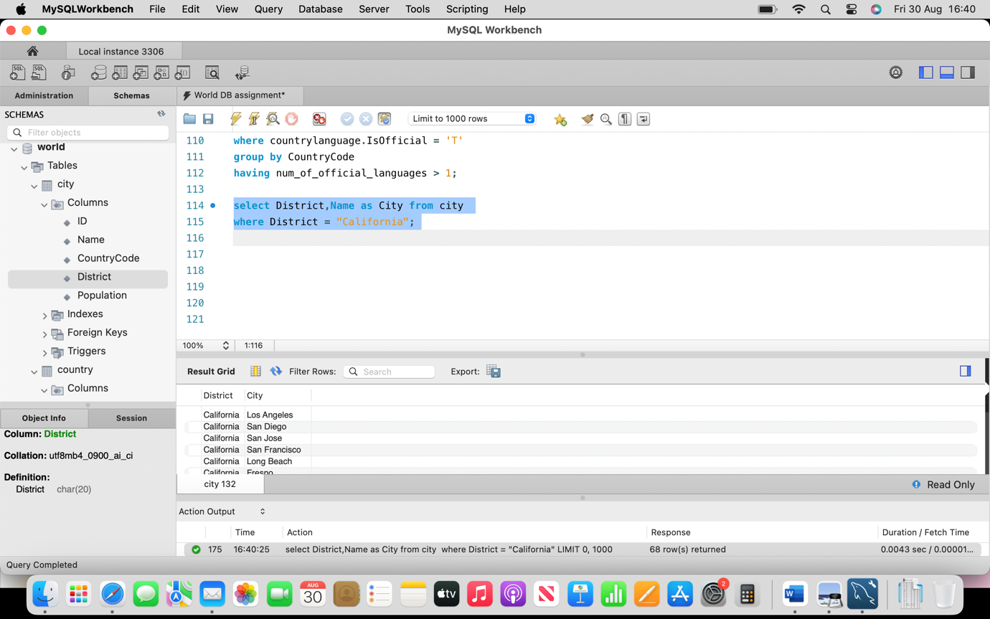

1. How do you find the countries with the highest population density?

Ans: 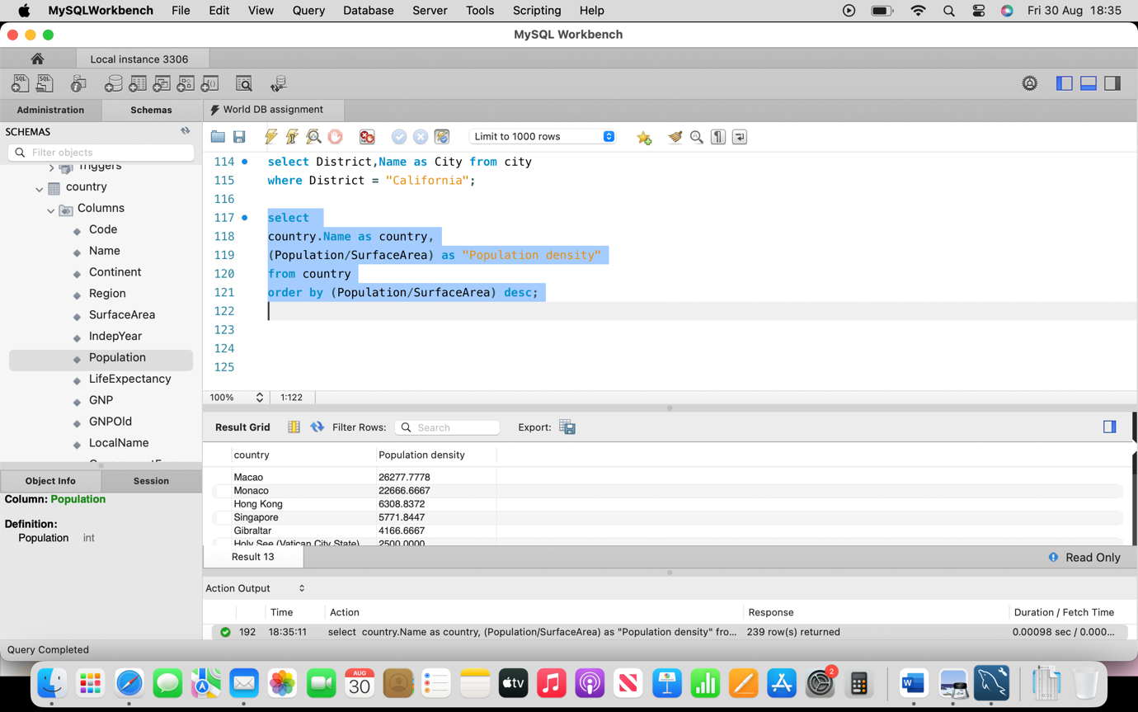

1. How do you find the countries with the lowest population density?

Ans: 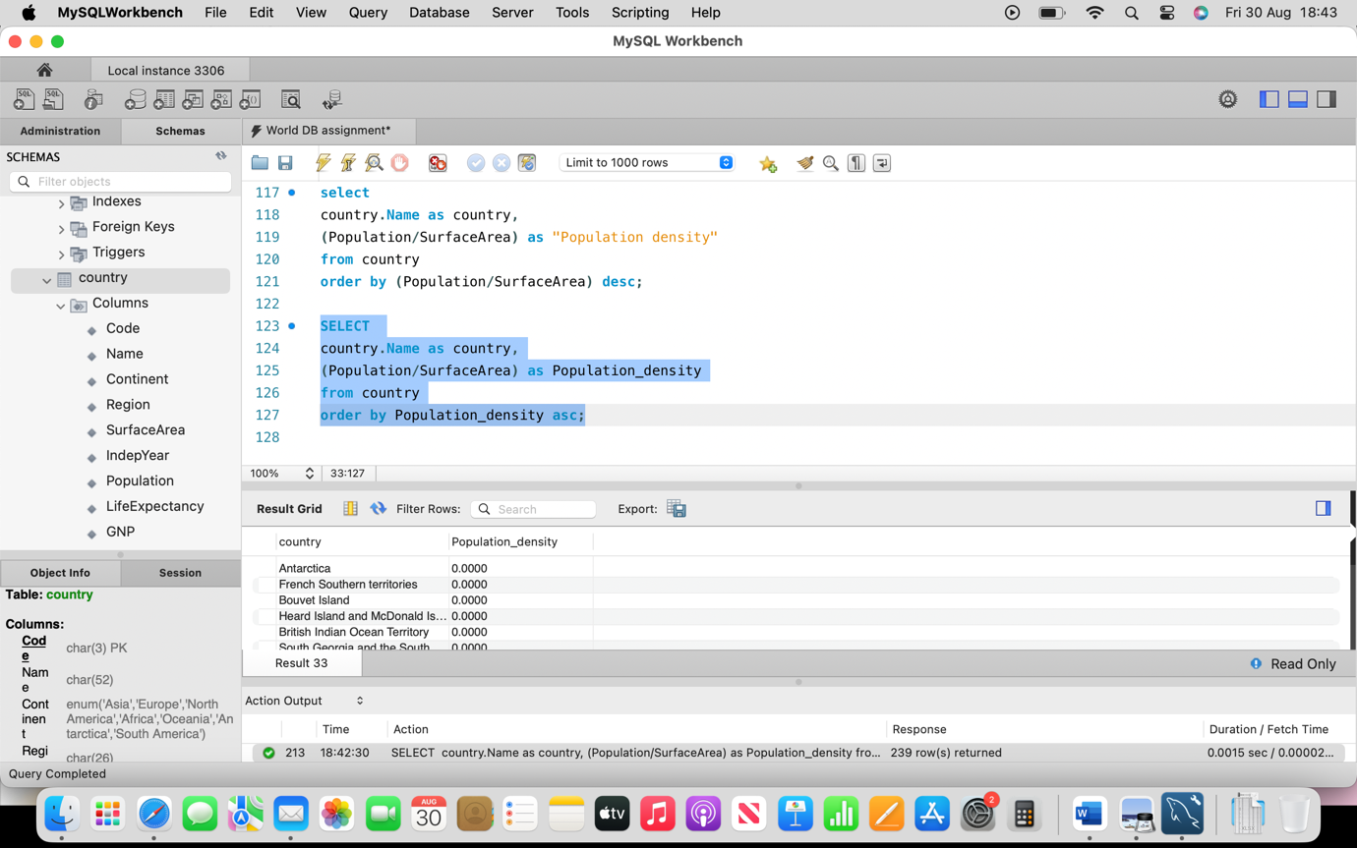

1. How do you find the countries with the highest GDP per capita?

Ans: 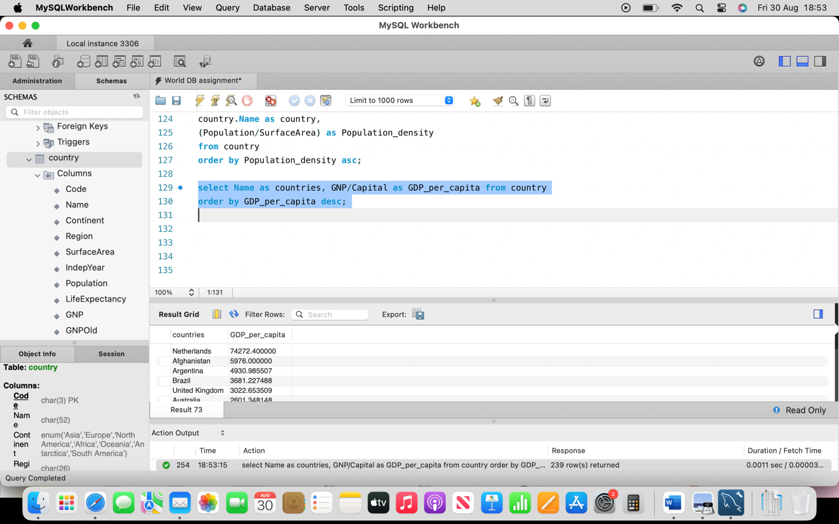

1. How do you find the countries with the lowest GDP per capita?

Ans: 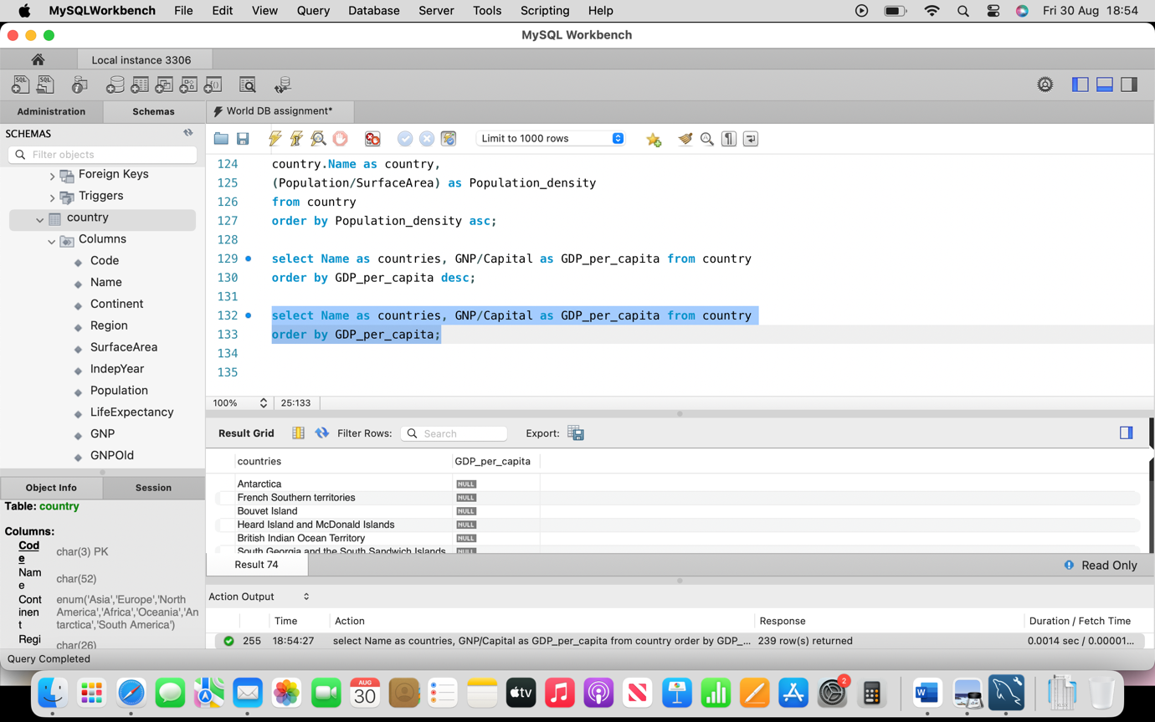

1. How do you find the countries with more than 5 official languages?

Ans: 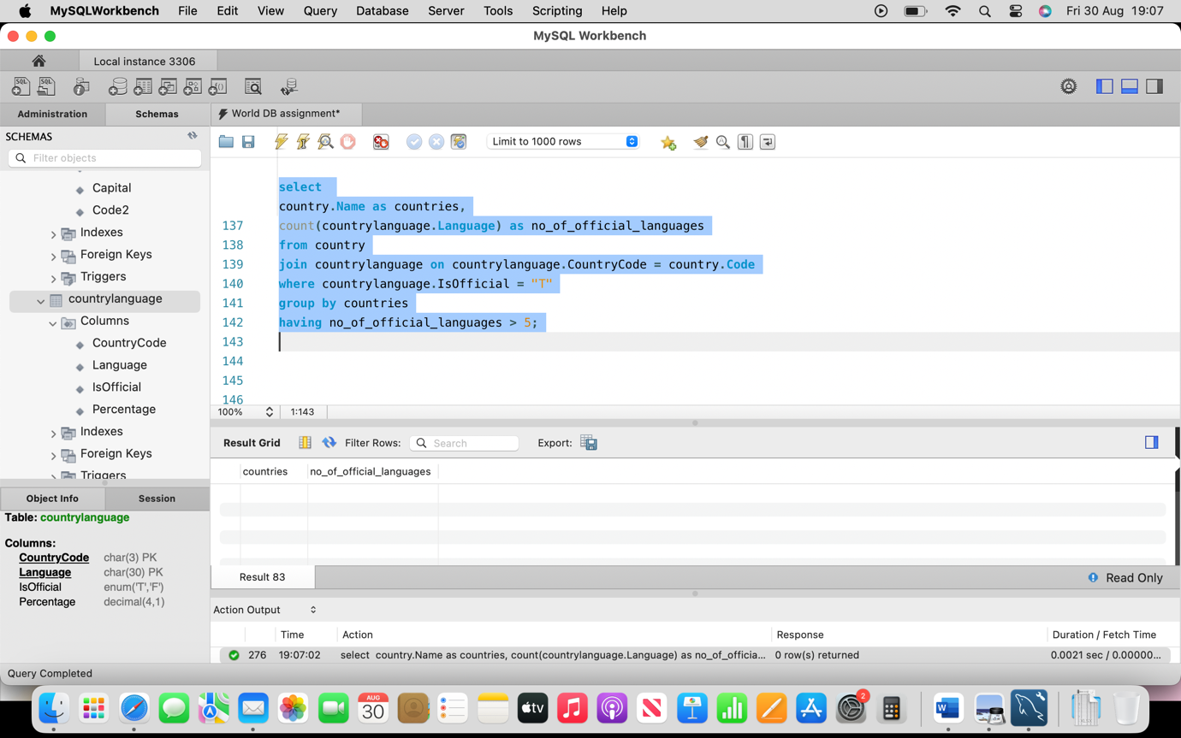

1. How do you find the countries with the highest life expectancy?

Ans: 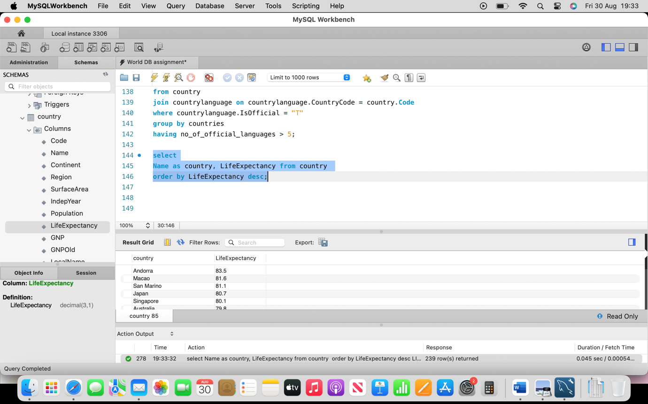

1. How do you find the countries with the lowest life expectancy?

Ans: 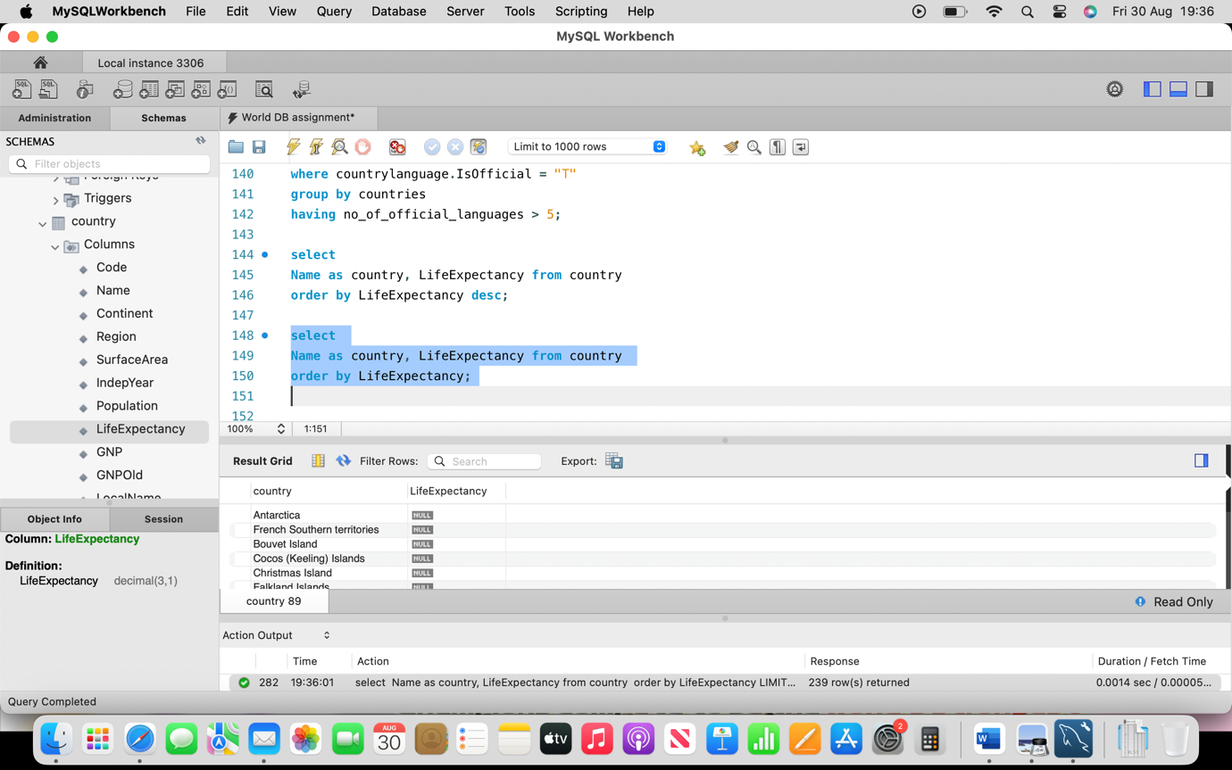

1. How do you find the countries with the most cities?

Ans: 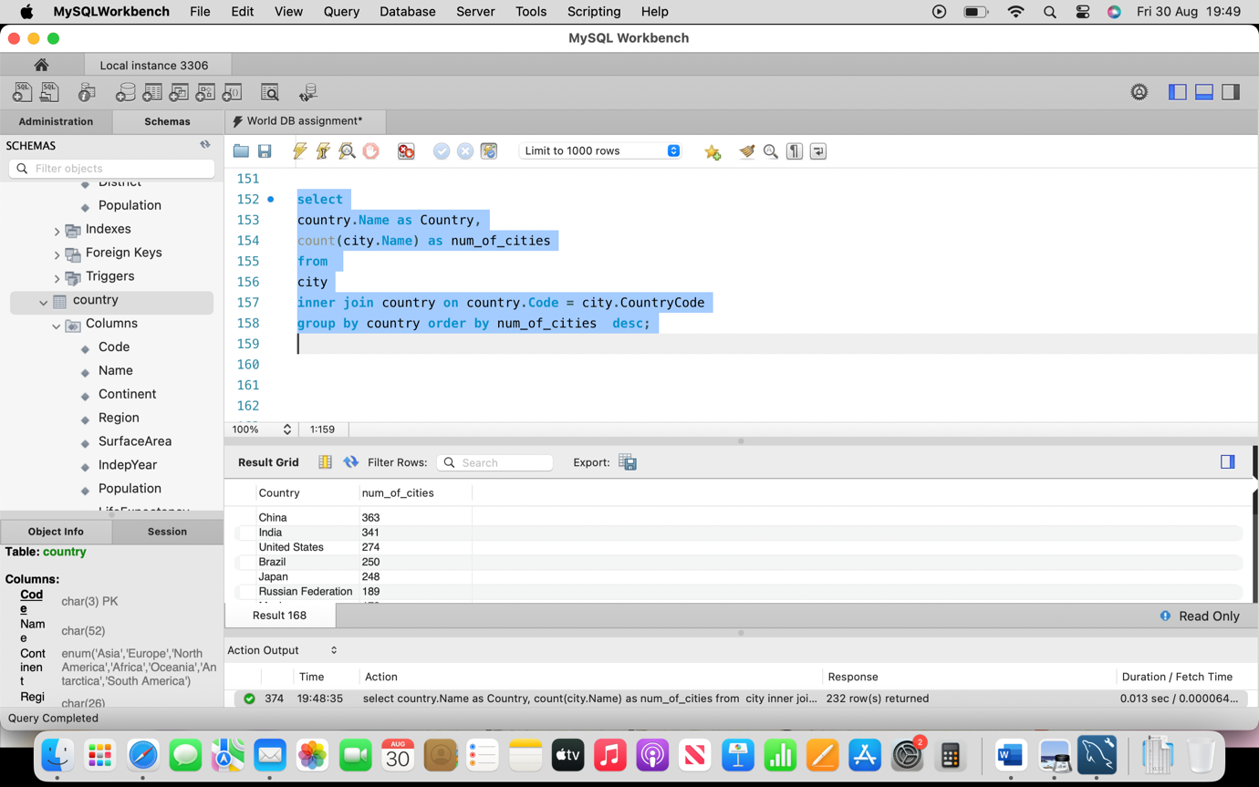

1. How do you find the countries with the least cities?

Ans: 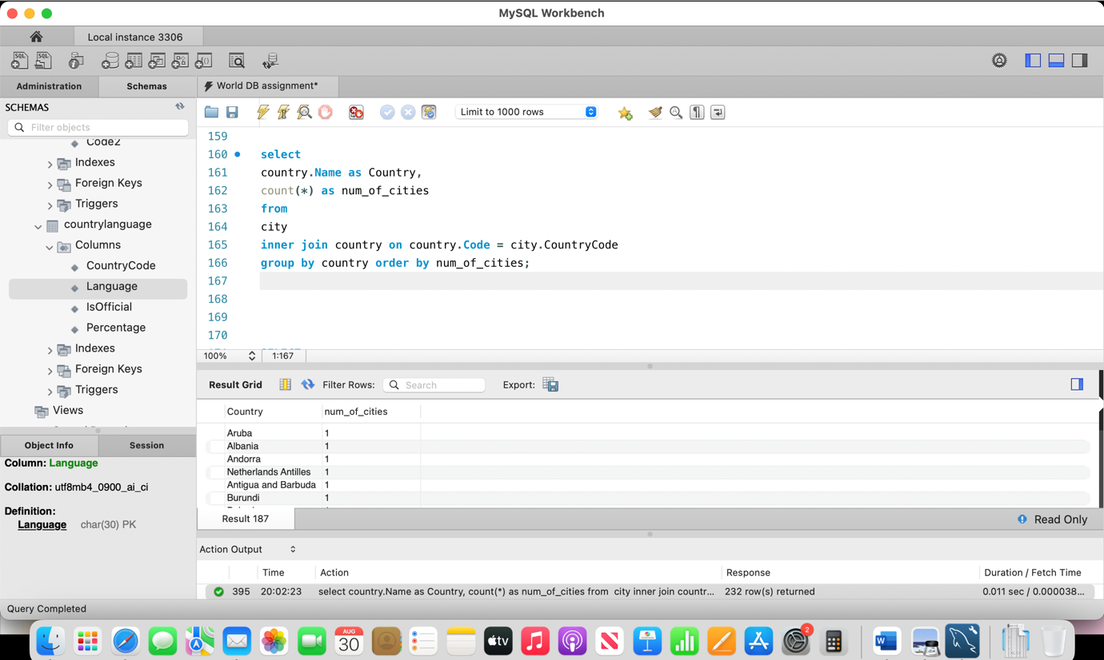

1. How do you find the countries with the highest number of languages spoken?

Ans: 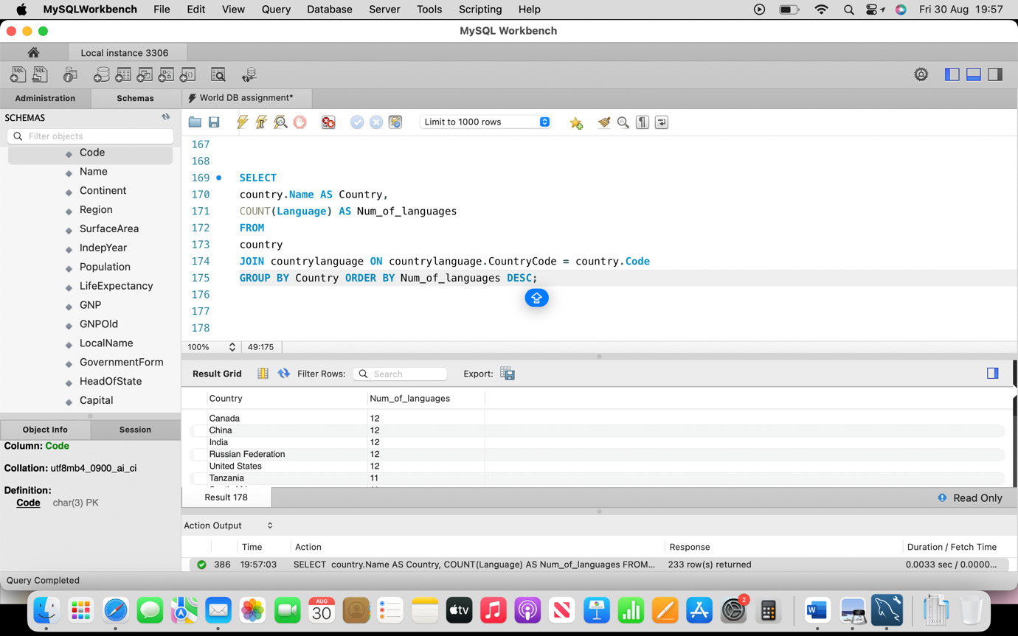

# Advanced Questions

## Questions

* 1. How do you find the population of countries with an official language of English?

Ans: 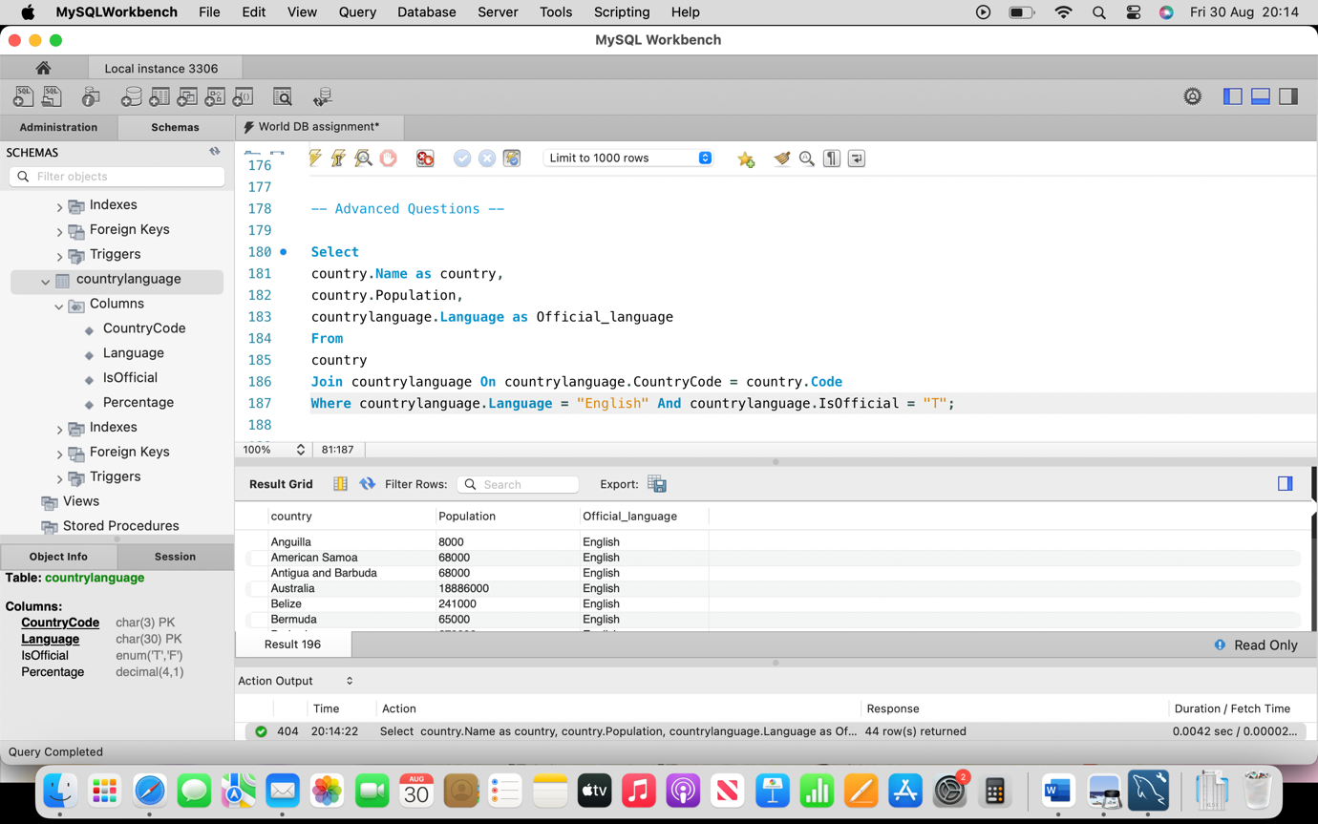

* 1. How do you find the top 5 most populated cities?

Ans: 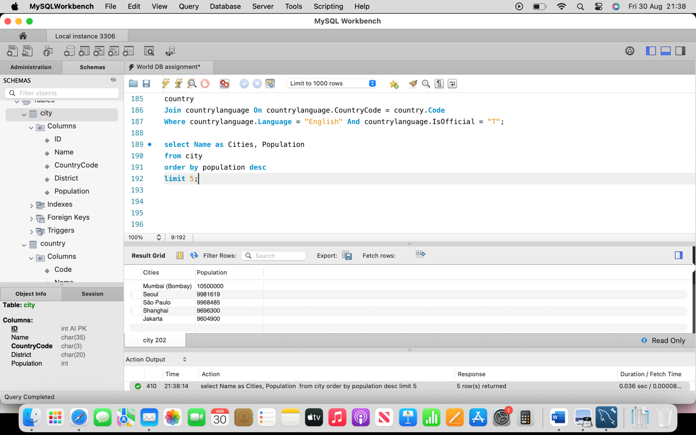

* 1. How do you find the countries with a ~~population~~ GDP growth rate greater than 2%?

Ans: 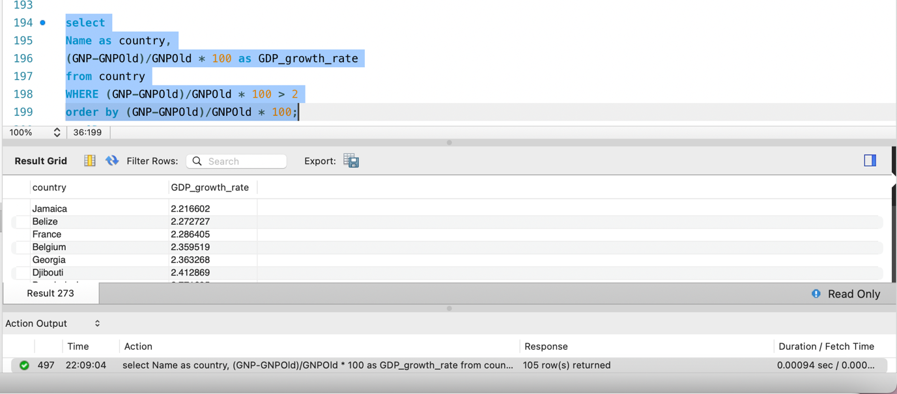

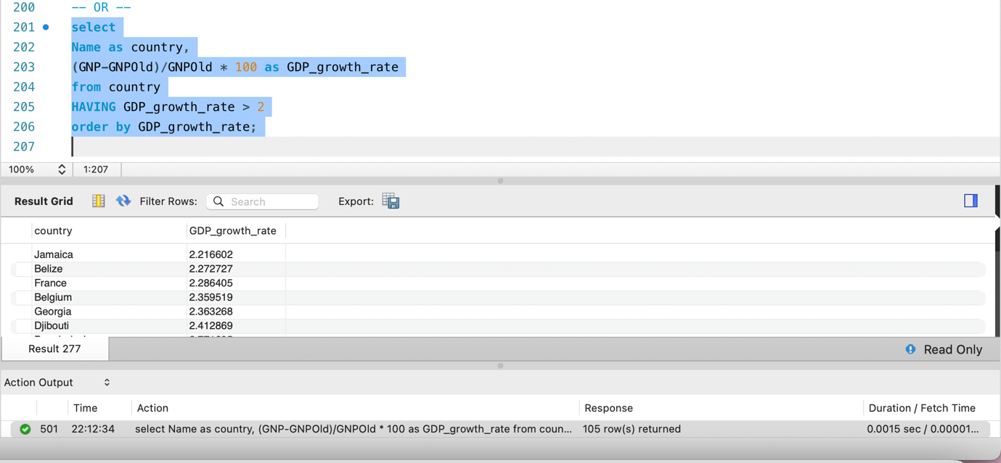

* 1. How do you find the countries with the highest number of official languages?

Ans: 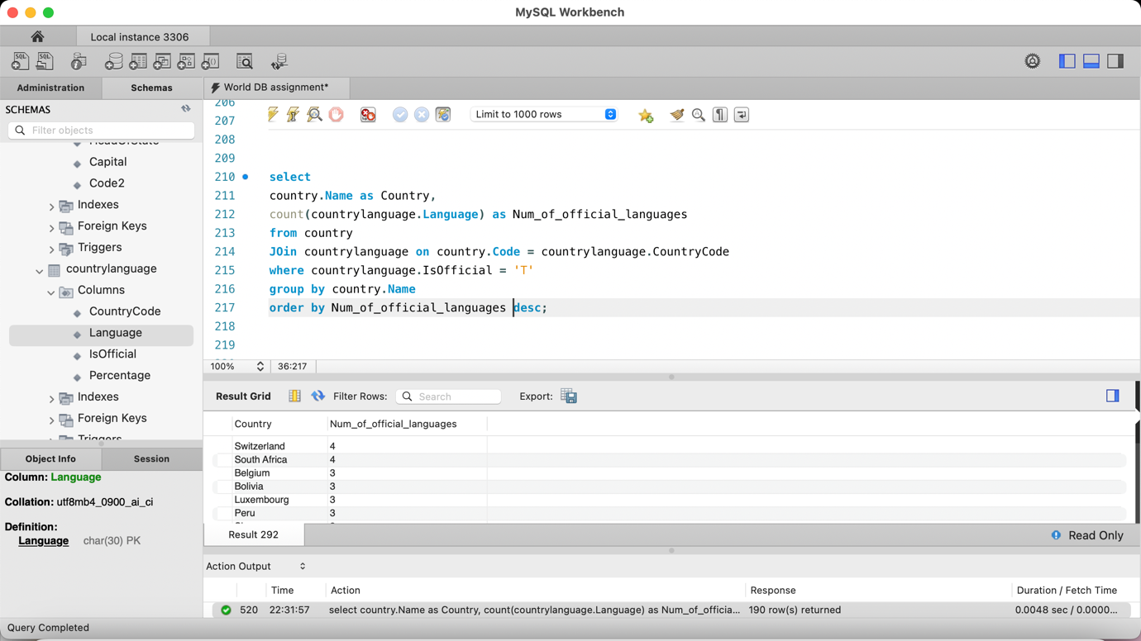

* 1. How do you find the countries with the most diverse languages?

Ans: 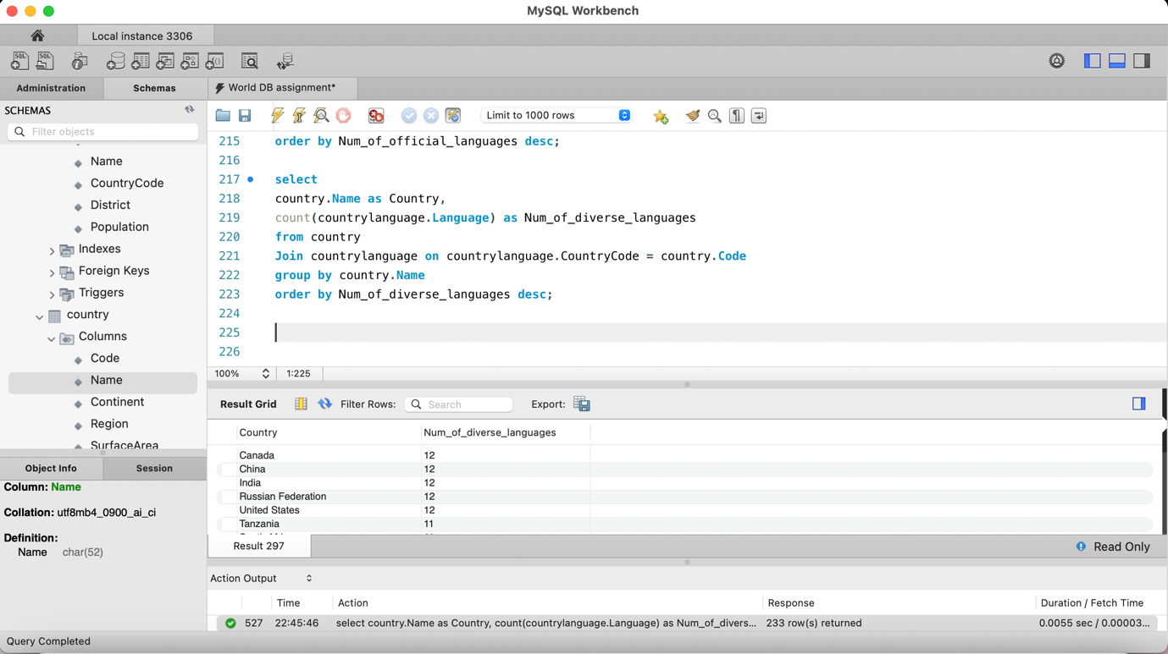

* 1. How do you find the countries with the highest number of cities with a population over 1 million?

Ans:

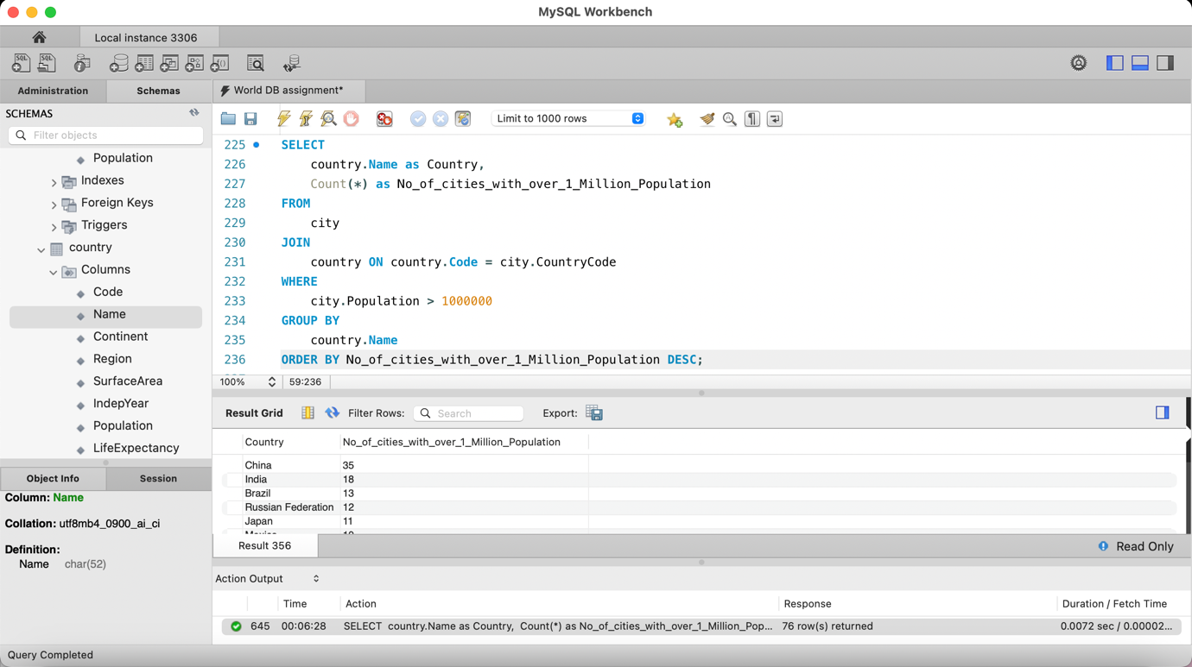

* 1. How do you find the countries with the highest number of cities with a population under 1 million?

Ans: 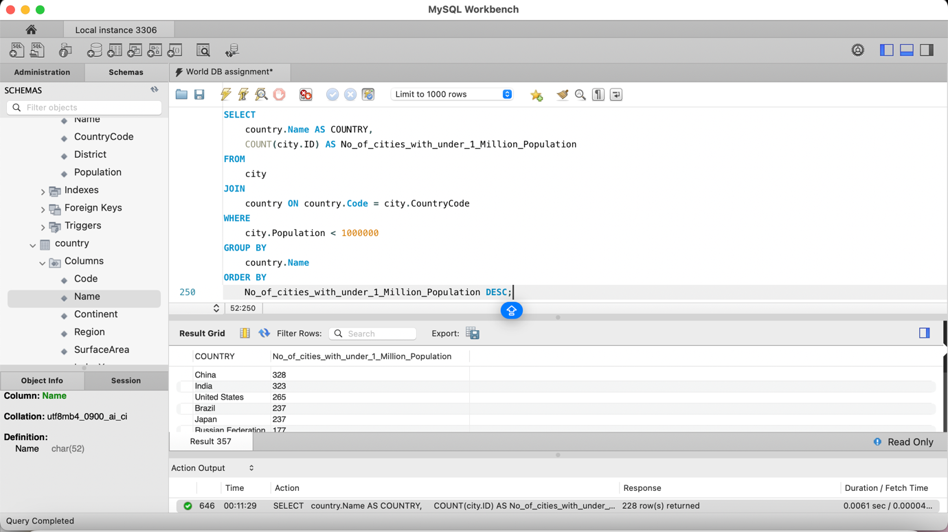

* 1. How do you find the countries with the highest number of cities with a population between 500,000 and 1 million?

Ans: 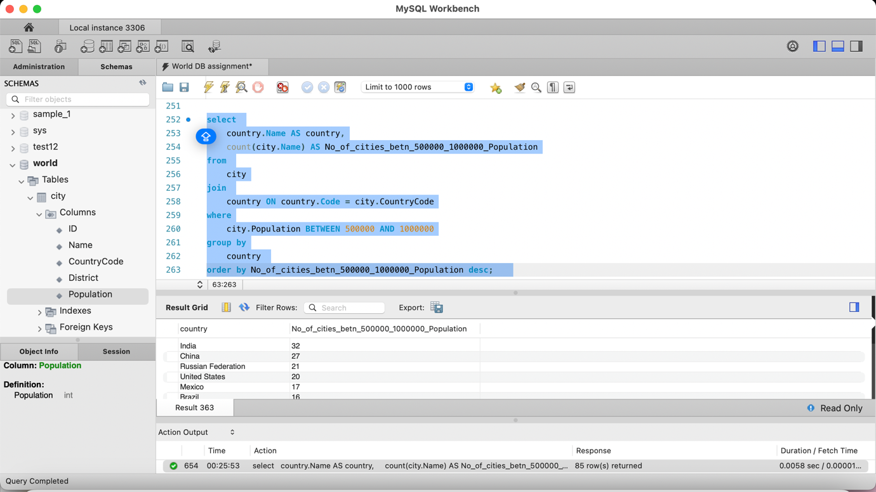

* 1. How do you find the countries with the highest number of cities with a population between 100,000 and 500,000?

Ans: 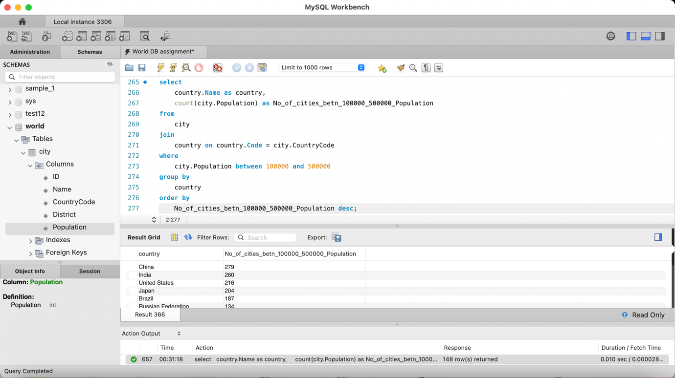

* 1. How do you find the countries with the highest number of cities with a population under 100,000?

Ans: 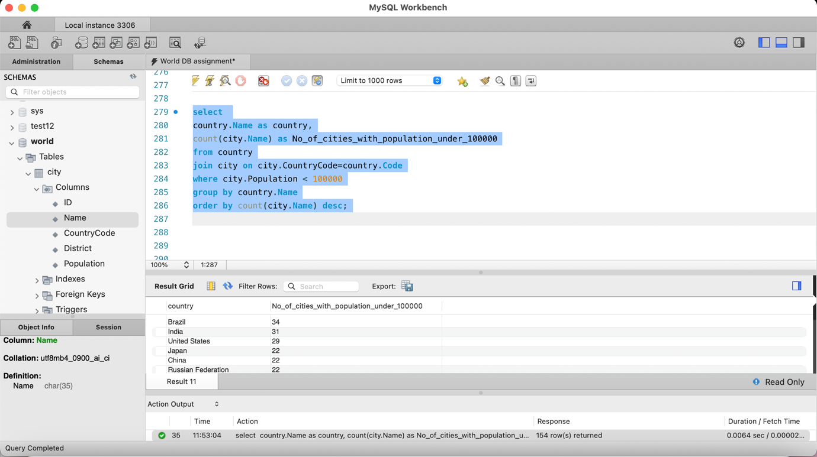

* 1. How do you find the countries with the highest number of cities with a population over 10 million?

Ans: 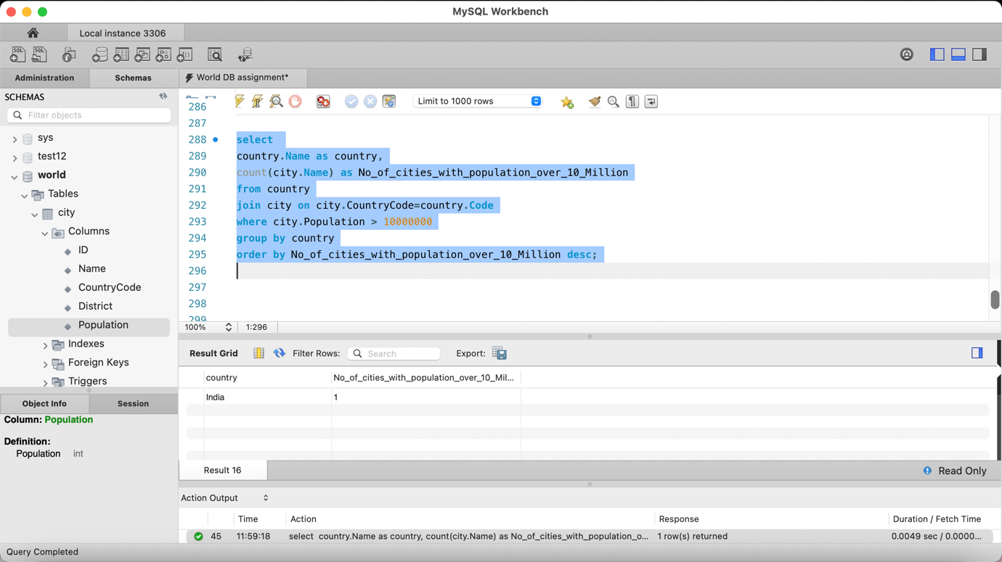

* 1. How do you find the countries with the highest number of cities with a population under 10 million?

Ans: 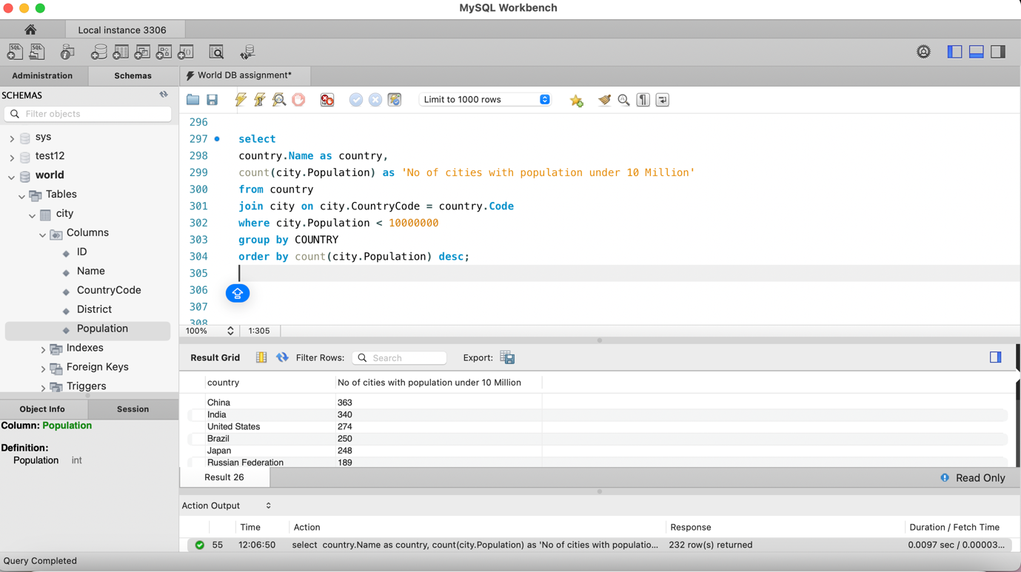

* 1. How do you find the countries with the highest number of cities with a population between 1 million and 10 million?

Ans: 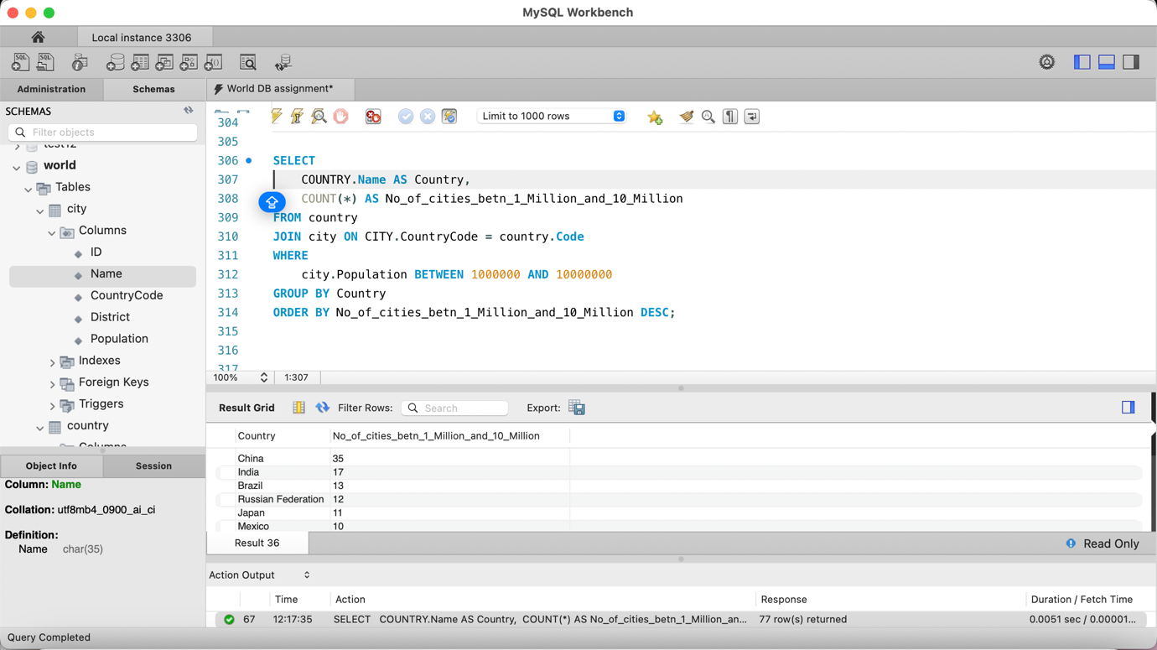

* 1. How do you find the countries with the lowest number of cities with a population between 500,000 and 1 million?

Ans: 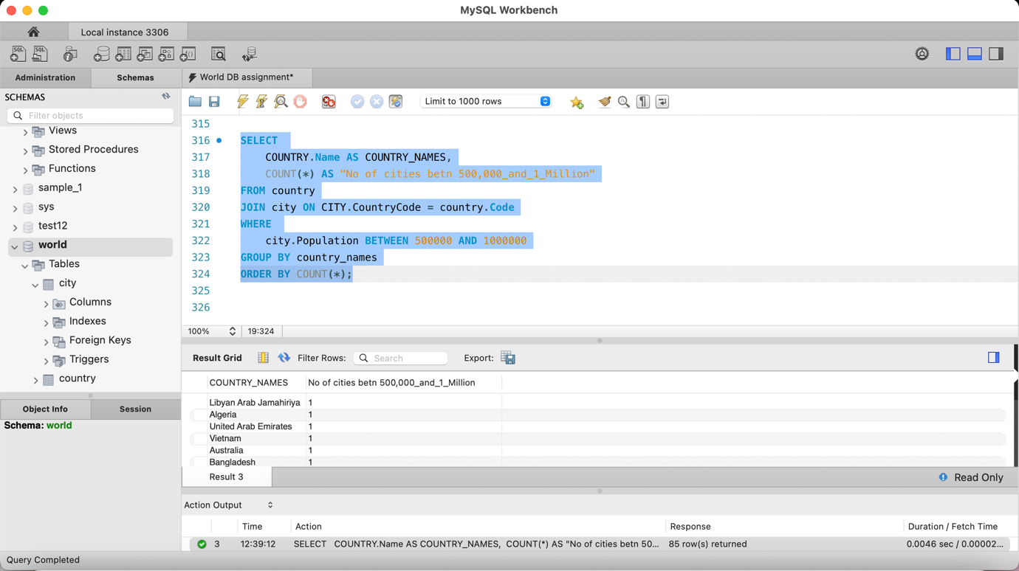

------------------------------**Repeated question**---------------------------

* 1. How do you find the countries with the highest number of cities with a population between 100,000 and 500,000?
  2. How do you find the countries with the highest number of cities with a population under 100,000?
  3. How do you find the countries with the highest number of cities with a population over 10 million?
  4. How do you find the countries with the highest number of cities with a population under 10 million?
  5. How do you find the countries with the highest number of cities with a population between 1 million and 10 million?
  6. How do you find the countries with the highest number of cities with a population between 500,000 and 1 million?
  7. How do you find the countries with the highest number of cities with a population between 100,000 and 500,000?
  8. How do you find the countries with the highest number of cities with a population under 100,000?
  9. How do you find the countries with the highest number of cities with a population over 10 million?
  10. How do you find the countries with the highest number of cities with a population under 10 million?
  11. How do you find the countries with the highest number of cities with a population between 1 million and 10 million?
  12. How do you find the countries with the highest number of cities with a population between 500,000 and 1 million?
  13. How do you find the countries with the highest number of cities with a population between 100,000 and 500,000?
  14. How do you find the countries with the highest number of cities with a population under 100,000?
  15. How do you find the countries with the highest number of cities with a population over 10 million?
  16. How do you find the countries with the highest number of cities with a population under 10 million?
  17. How do you find the countries with the highest number of cities with a population between 1 million and 10 million?
  18. How do you find the countries with the highest number of cities with a population between 500,000 and 1 million?
  19. How do you find the countries with the highest number of cities with a population between 100,000 and 500,000?
  20. How do you find the countries with the highest number of cities with a population under 100,000?
  21. How do you find the countries with the highest number of cities with a population over 10 million?
  22. How do you find the countries with the highest number of cities with a population under 10 million?
  23. How do you find the countries with the highest number of cities with a population between 1 million and 10 million?
  24. How do you find the countries with the highest number of cities with a population between 500,000 and 1 million?
  25. How do you find the countries with the highest number of cities with a population between 100,000 and 500,000?
  26. How do you find the countries with the highest number of cities with a population under 100,000?
  27. How do you find the countries with the highest number of cities with a population over 10 million?
  28. How do you find the countries with the highest number of cities with a population under 10 million?
  29. How do you find the countries with the highest number of cities with a population between 1 million and 10 million?
  30. How do you find the countries with the highest number of cities with a population between 500,000 and 1 million?
  31. How do you find the countries with the highest number of cities with a population between 100,000 and 500,000?
  32. How do you find the countries with the highest number of cities with a population under 100,000?
  33. How do you find the countries with the highest number of cities with a population over 10 million?
  34. How do you find the countries with the highest number of cities with a population under 10 million?
  35. How do you find the countries with the highest number of cities with a population between 1 million and 10 million?
  36. How do you find the countries with the highest number of cities with a population between 500,000 and 1 million?
  37. How do you find the countries with the highest number of cities with a population between 100,000 and 500,000?
  38. How do you find the countries with the highest number of cities with a population under 100,000?
  39. How do you find the countries with the highest number of cities with a population over 10 million?
  40. How do you find the countries with the highest number of cities with a population under 10 million?
  41. How do you find the countries with the highest number of cities with a population between 1 million and 10 million?
  42. How do you find the countries with the highest number of cities with a population between 500,000 and 1 million?
  43. How do you find the countries with the highest number of cities with a population between 100,000 and 500,000?
  44. How do you find the countries with the highest number of cities with a population under 100,000?
  45. How do you find the countries with the highest number of cities with a population over 10 million?
  46. How do you find the countries with the highest number of cities with a population under 10 million?